
Twins BMC Firmware Specification


TWINS BMC FIRMWARE SPECIFICATION

VERSION 1.3

CESBG/CABG

HON HAI PRECISION IND. CO., LTD

Released Date: 2018.Aug

HON HAI Precision Industry Co., Ltd. | Doc. No.
CESBG R&D Division Server | Rev.1.1Page 0/54

Twins BMC Firmware Specification

REVISION HISTORY

Revision | Affected |  | Revision History | Date
 | Section
0.1 |  | draft version |  | 2017/2/13
0.2 |  | Enhance sensor information |  | 2017/4/18
0.3 |  | Update sensor information |  | 2017/6/16
0.4 |  | 1.Modify Sensor setting & data |  | 2017/07/05
 |  | 2.Add new sensor: PS1_Temp. PS2_Temp
0.5 |  | 1.Modify sensor name for different use |  | 2017/07/07
 |  | 2.Rmove Redfish spec
0.6 |  | 1.Modify sensor name & sensor number for consistency with other |  | 2017/08/28
 |  |  | project
0.7 |  | Modify sensor threshold & sensor name |  | 2017/11/01
0.8 |  | 1. | Modify Device ID – 00168Bh to 0056DEh | 2018/01/18
 |  | 2. | Modify Temp Sensor threshold
0.9 |  | 1. | Add Twins Skew4 | 2018/02/07
1.0 |  | 1. | Update block diagram | 2018/04/09
 |  | 2. | Add OCP temp sensor
 |  | 3. | Modify LED behavior when KVM enabled
1.1 |  | 1. | Update Sensor Table | 2018/8/10
1.2 |  | 1. | Update Sensor Table | 2019/01/15
1.3 |  | 1. | Update Sensor TablE。2.Update OEM cmd table. | 2019/09/03

HON HAI Precision Industry Co., Ltd. | Doc. No.
CESBG R&D Division Server | Rev.1.1Page 1/54

Twins BMC Firmware Specification

HON HAI Precision Industry Co., Ltd. | Doc. No.
CESBG R&D Division Server | Rev.1.1Page 2/54

Twins BMC Firmware Specification

Table of Contents

REVISION HISTORY 1

GLOSSARY & ABBREVIATION 6

SCOPE 7

CHAPTER 1. HARDWARE 8

1.1. SYSTEM SPECIFICATIONS 8

1.2. PLATFORM MAIN COMPONENTS RELATED TO IBMC 8

1.3. I2C BLOCK DIAGRAM 10

1.3.1. I2c Bus Access 10

CHAPTER 2. GENERAL FEATURES 12

2.1. IPMI MESSAGING INTERFACE 12

2.1.1. Channel Management 12

2.1.2. LPC/KCS 12

2.1.3. LAN Messaging 12

2.1.4. Serial/Modem Interface 13

2.1.5. Intelligent Platform Management Bus (IPMB) 13

2.1.6 Users & Password Support 13

2.2. PLATFORM MONITORING 14

2.2.1. Analog/I2c/TACH Sensors 14

2.2.2. Discrete Sensor 15

2.2.3. Event Only sensor 15

2.3. PLATFORM CONTROL 15

2.3.1. Chassis Control 15

2.3.2. LED 16

2.3.3. Buttons 16

2.4. SYSTEM EVENT LOG(SEL) AND EVENT MESSAGES 17

2.4.1. Event Logging Disabled Sensor 17

2.4.2. IPMI SEL Time 17

2.5. PLATFORM EVENT FILTERING (PEF) AND ALERT POLICIES 18

2.5.1. Alert Policy Table 18

2.5.2. Alert String Keys and Alert Strings (TBD) 19

2.5.3. PEF Action PEF Action 19

2.5.4. Event Processing When the SEL Is Full 20

HON HAI Precision Industry Co., Ltd. Doc. No.

CESBG R&D Division Server Rev. 1.1 Page 3/54
Twins BMC Firmware Specification

2.6. FRU 20

2.6.1. FRU Devices & Access Information 20

2.6.2. FRU Byte Definition 20

2.7. SOL 20

2.8. FIRMWARE UPDATE 21

2.8.1. BMC FW 21

2.8.2. Others 23

2.9. WEB GUI 24

2.9.1. Specification 24

2.9.2. Supported Web Browser 24

2.10. WATCHDOG TIMER ACTIONS 24

2.10.1. Pre-timeout Interrupt 24

2.10.2. Watchdog Timer Event Logging 24

2.10.3. Common Usage in System 24

2.10.4. HW WDT for IBMC 25

2.11. SERIAL REDIRECTION 25

2.11.1. KVM Redirection 25

2.12. FSC (FAN SPEED CONTROL) 26

2.12.1. Sensors and Fans 26

2.12.2. Open Loop Control Policy 26

2.12.3. Close Loop Control Policy 26

2.12.4. Threshold Definition 27

2.13. SECURITY 27

2.13.1. firmware firewall 27

2.14. VIRTUAL MEDIA 28

2.15. SMASH-CLP 28

2.16. IBMC FIRMWARE AND BIOS INTERFACE 28

CHAPTER 3. CUSTOMERS FEATURES 30

3.1. CUSTOMERS’ FEATURE SUPPORT LIST 30

3.2. BMC FIRMWARE NAMING 30

APPENDIX A IBMC HARDWRE: AST2500 31

APPENDIX B IPMI COMMANDS SUPPORT TABLE 34

APPENDIX C IPMI OEM COMMANDS LIST 38

APPENDIX D FRU DATA 39

HON HAI Precision Industry Co., Ltd. Doc. No.

CESBG R&D Division Server Rev. 1.1 Page 4/54
Twins BMC Firmware Specification

D.1 .FRU DATA TEMPLATE 39

D.2 FRU BYTE DEFINITION 39

APPENDIX E SENSOR TABLE 45

APPENDIX F DEFAULT CONFIGURATION 51

APPENDIX G PRODUCT IDENTIFICATION 52

APPENDIX H REFERENCES 53

HON HAI Precision Industry Co., Ltd. | Doc. No.
CESBG R&D Division Server | Rev.1.1Page 5/54

Twins BMC Firmware Specification

GLOSSARY & ABBREVIATION

 | Glossary & Abbreviation | Explanation
 | BMC | Baseboard Management Controller, this is the common abbreviation for an
 |  | IPMI Baseboard Management Controller
 | IBMC | Integrated Baseboard Management Controller, this is the name for the 2nd
 |  | generation of IBMC hardware, we use AST2500 on Platform
 | IMM | Integrated Management Module, this means the same as IBMC
 | IPMI | Intelligent Platform Management Interface, a standardized system
 |  | management interface
 | IPMB | Intelligent Platform Management Bus, I2C based bus
 | SOL | Serial Over LAN, Host serial port traffic redirected over a LAN connection for
 |  | remote control and management
 | SDR | Sensor Data Record, A data record that provides platform management
 |  | sensor type, locations, event generation, and access information
 | Serial Port Sharing | Ability to share a serial connector between the iBMC’s serial controller and a
 |  | system serial controller by using circuitry to allow it to be switched between
 |  | the two
 | POST | Power On Self Test
 | OEM | Original Equipment Manufacturer
 | FRU | Field Replaceable Unit
 | VPD | Vital Product Data, this is the term given to system component
 |  | manufacturing information such as, but not limited to, serial number and
 |  | FRU part number
 | SEL | System Event Log
 | SMS | System Management Software
 | SMM | System Management Mode
 | NMI | Non Maskable Interrupt
 | SMI | System Management Interrupt
 | IERR | Internal Error. A signal from the Intel Architecture processors indicating an
 |  | internal error condition
 | PERR | Parity Error. A signal on the PCI bus that indicates a parity error on the bus
 | SERR | System Error. A signal on the PCI bus that indicates a ‘fatal’ error on the bus
 | PECI | Platform Environment Control Interface
 | FRB | Fault Resilient Booting

HON HAI Precision Industry Co., Ltd. | Doc. No.
CESBG R&D Division Server | Rev.1.1Page 6/54

Twins BMC Firmware Specification

SCOPE

This document describes Twins BMC and implementation specification. This documents does not describe every detail of a general BMC implementation, but only those specific to Twins projects. For those features and implementation that were implemented in Spirit series will be referred to but will not be described.

Audience:

This specification is intended for the following audiences:
- Server Management Firmware Engineers

- System BIOS Engineers

- Diagnostic Software and Utilities Engineers

- Validation Engineers

- OEM Design Engineers

HON HAI Precision Industry Co., Ltd. | Doc. No.
CESBG R&D Division Server | Rev.1.1Page 7/54

Twins BMC Firmware Specification

CHAPTER 1. HARDWARE

1.1.SYSTEM SPECIFICATIONS

Refer to

1.

System Block Diagram
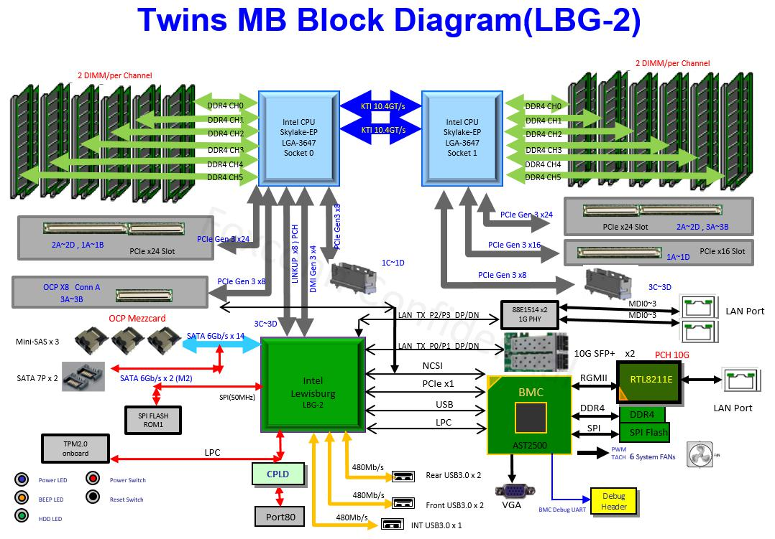

Figure 1-1 System block diagram

1.2.PLATFORM MAIN COMPONENTS RELATED TO IBMC

 | Table 1-1 Main component related to BMC
 | Intel Purley platform |  | - CPU(Skylake-EP) + PCH(Lewisburg)
 | Intel Purley platform |  | - NM4.0 supported
 | IBMC |  | AST2500 (refer to Appendix A)
 |  |  | BIOS side:
 |  |  | W25Q256FVFIQ (32M, U109, primary)
 | Flash ROM |  | W25Q256FVFIQ (32M, U59, secondary)
 |  |  | BMC side:
 |  |  | MX25L25635FM (32M, U90)
HON HAI Precision Industry Co., Ltd. |  |  | Doc. No.
CESBG R&D Division Server |  |  | Rev.1.1 | Page 8/54

 | Twins BMC Firmware Specification
Memory | MT40A512M16HA (1GB)
LAN | RMII1: IBMC dedicated LAN. PHY RTL8211E
LAN | RMII2: Share NIC. OCP Mezz slot (J18)
FRU device | CAT24C64 (8KB)
 | Refer to EE / CPLD GPIO table:
GPIO/SGPIO | 1. BMC AST2500 PIN MAP20161022.xlsx
 | 2. TWINS_BMC AST2500 PIN MAP20170110.xlsx
 | UART1: System UART (J8)
UART | UART2: CM console (J17)
 | UART5: BMC console (J29)
 | System Health LED (Green/Amber)
LED | BMC HeartBeat LED
 | UID LED
 | Power button
Button | System Reset button
 | UID/BMC Reset button
 | Board Ver ID: 3 GPIO pins are used as FM_FAB_REV_ID[2:0] (connect to
IDs | BMC)
 | Board SKU ID: 3 GPIO pins are used as FM_SKU_ID[2:0] (connect to PCH)
CPLD | Lattice LCMXO3LF-2100C
VR controllers | TPS53659
VR controllers | TPS53626
Firmware Vendor of Code Base | AMI MegaRAC 11.6

HON HAI Precision Industry Co., Ltd. | Doc. No.
CESBG R&D Division Server | Rev.1.1Page 9/54

Twins BMC Firmware Specification

1.3.I2C BLOCK DIAGRAM
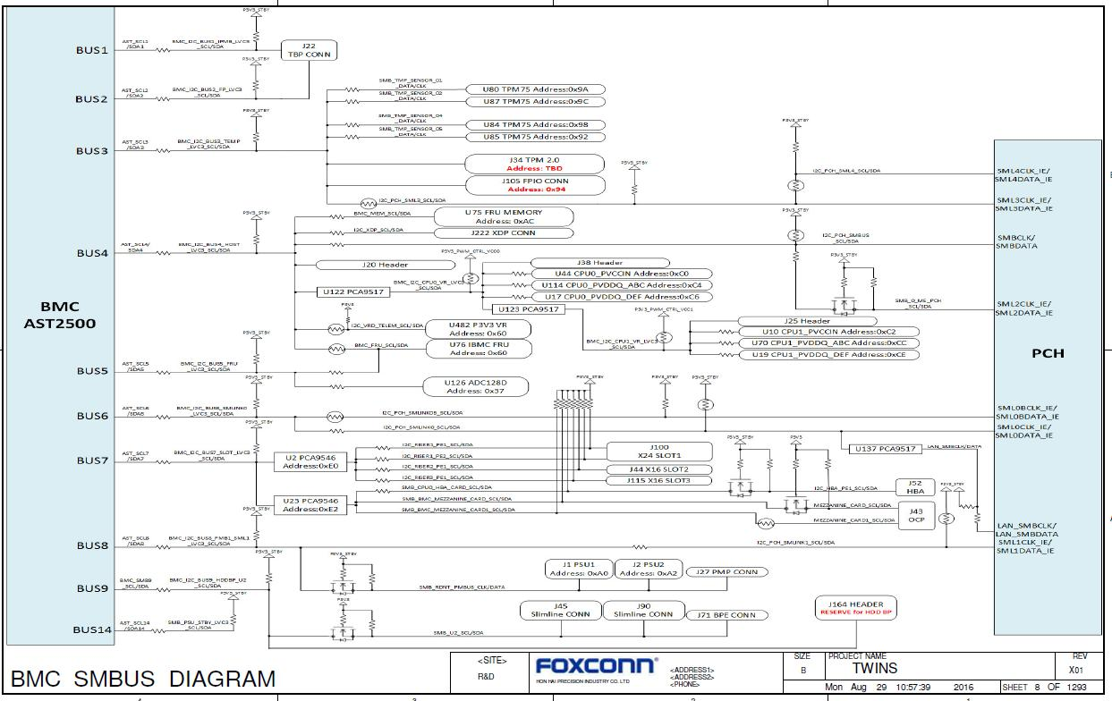

Figure 1-2 I2c block diagram

1.3.1.I2c Bus Access

IPMI provides the Master Write-Read I2C command (IPMIv2.0 Section 22.11 Master Write-Read Command) for generic I2C access to the IBMC’s private busses as well as the IPMB. The bus identifiers for Twins platform are listed in the below table. It should be noted that this command is only available to get to the physical busses attached to the IBMC. The state of any downstream MUX is not guaranteed and so great caution should be taken if this command is used to communicate with a bus on which a MUX is present.

Table 1-2 Master Write-Read Bus IDs

 |  | Physical |  |  | Bus ID (channel no + |  |  | Slave address |  |  | BMC use? |  |  | Remark
 |  | Bus Number |  |  | bus ID + bus type) |  |  | Slave address |  |  | (V)
 | 1 |  |  |  | 01h |  |  |  |  |  |  |  |  | 2x6 SAS Expander
 |  |  |  |  |  |  |  | 0x58 / 0x5E |  |  | V |  |  | ADT7470 (FCB)
 |  |  |  |  |  |  |  | 0x34 / 0x38 |  |  |  |  |  | PCA9557 (FCB)
 |  |  |  |  |  |  |  | TBD |  |  |  |  |  | CPLD (CPLD DB)
HON HAI Precision Industry Co., Ltd. |  |  |  |  |  |  |  |  |  |  |  |  |  | Doc. No.
CESBG R&D Division Server |  |  |  |  |  |  |  |  |  |  |  |  |  | Rev.1.1 | Page 10/54

Twins BMC Firmware Specification

2 | 03h | 0xA0 |  | MB FRU (PIB)
 |  | 0x98 |  | Temp sensor (PIB)
3 | 05h | 0x9A | V | Temp sensor
 |  | 0x9C | V | Temp sensor
 |  | 0x98 | V | Temp sensor
 |  | 0x92 | V | Temp sensor
4 | 07h | 0xAC |  | FRU memory
 |  | 0xD0 |  | VR CPU0 PVCCIN
 |  | 0xC4 |  | VR CPU0 PVDDQ ABC
 |  | 0xC6 |  | VR CPU0 PVDDQ DEF
 |  | 0xD4 |  | VR CPU1 PVCCIN
 |  | 0xCC |  | VR CPU1 PVDDQ ABC
 |  | 0xCE |  | CPU1 PVDDQ DEF
5 | 09h | 0xA0 | V | IBMC FRU
 |  | 0x37 |  | ADT128 Voltage Sensor
6 | 0Bh | 0x2C | V | PCH SMLink0
7 | 0Dh | 0xE0 |  | PCA9546A
 |  |  |  | OCP MEZZ connector
 |  |  |  | PCIE x16 Riser
 |  |  |  | Extend Connector
8 | 0Fh | 0x80 | V | SN13110

HON HAI Precision Industry Co., Ltd. | Doc. No.
CESBG R&D Division Server | Rev.1.1Page 11/54

Twins BMC Firmware Specification

CHAPTER 2. GENERAL FEATURES

2.1.IPMI MESSAGING INTERFACE

2.1.1.Channel Management

IPMI uses a ‘channel model’ for directing communication between different interfaces in the BMC. Channels serve as the means for identifying the medium for a messaging interface, and for configuring user information and passwords, message authentication, access modes and privilege limits associated with that interface. Please refer to the IPMIv2.0 for more detail information. The common assignments of all channels are shown in below table.

Table 2-1 Channel Assignments

Interface | Channel Number | Supports Sessions
IPMB | 00h | Yes
LAN | 01h | Yes
LAN(NCSI) | 08h | Yes
Serial Channel | 02h | Yes
Host/SMS interface | 0Fh | No

2.1.2.LPC/KCS

The IBMC FW supports 3 KCS interfaces. These interfaces are mapped into the host I/O space and can be accessed through the LPC bus by host. These interfaces are assigned with the following usages and I/O addresses:

Table 2-2 KCS Interface

Name | Usage | Address
Host/SMS Interface | SMS, BIOS POST, and utility access | CA2h/CA8h/CA0h

Note: The location of the KCS registers and the I2C address of the IBMC will be reported through a Type 38 SM BIOS table entry.

2.1.3.LAN Messaging

BMC receives and responds IPMI messages via RGMII which connects BMC with on board external PHY. The channel number of LAN messaging is 01h.

2.1.3.1.Firmware MAC Address

The MAC address will be programmed in an external EEPROM during manufacturing. And it is read only for the end user. “PS list” command of u-boot is used to show the detail configuration for the firmware developer. The bus number is 5

HON HAI Precision Industry Co., Ltd. | Doc. No.
CESBG R&D Division Server | Rev.1.1Page 12/54

Twins BMC Firmware Specification

on which the chip of MAC address is and the chip slave address is 0xA0. The offset of MAC0 address (Dedicate LAN) in EEPROM is 0x1C00.The offset of MAC1 address (share LAN) in EEPROM is 0x1C08.

2.1.4.Serial/Modem Interface

Transmission of IPMI messages between a remote console and the BMC is in one of three configurable modes:

Basic Mode, PPP Mode, and Terminal Mode.

Basic Mode This mode uses a simple clear text password to activate a session. IPMI messages are encoded and delimited using a simple framing scheme based on ‘escaped’ characters. Basic Mode is the most efficient standard operating mode for enabling a remote console application to communicate with the BMC using IPMI messages.

PPP/UDP Mode This mode uses the same session and authentication operation as IPMI over LAN. It uses PPP as the protocol for establishing a point-to-point communications link over which IPMI messages are sent encapsulated in UDP datagrams. This mode incurs significant overhead in message size and handshake complexity beyond that required for Basic Mode IPMI messaging, but has the advantage of using a widely supported standard.

Terminal Mode This mode is intended primarily for direct serial connection operation. The mode is designed so that a simple terminal or terminal emulator can be used to generate requests and get responses from the BMC.

2.1.5.Intelligent Platform Management Bus (IPMB)

When an IPMB is implemented in the system, the BMC serves as a controller to give system software access to the IPMB. The IPMB allows non-intelligent devices as well as management controllers on the bus. To support this operation, the BMC provides the master Write-Read command via its interface with system software. The Master Write-Read command provides low-level access to non-intelligent devices on the IPMB, Such as FRU SEEPROMS.

The Master Write-Read command provides a subset of the possible IIC and SMBus operations that covers most IIC/SMBus-compatible devices.

In addition to supporting non-intelligent devices on the IPMB, the Master Write-Read command also provides access to non-intelligent device on Private Busses behind management controllers. The main purpose of this is to support FRU SEEPROMs on Private Busses.

By default the IBMC will respond at address 20h on this bus, and the IPMB will be channel number 00h as required by the IPMIv2.0 specification.

2.1.6 Users & Password Support

The IBMC FW supports the IPMI 2.0 user model including User ID 1 support. 10 user IDs are supported. These 10 users can be assigned to any channel. The following restrictions are placed on user-related operations:

HON HAI Precision Industry Co., Ltd. | Doc. No.
CESBG R&D Division Server | Rev.1.1Page 13/54

Twins BMC Firmware Specification

1. User names for User ID 1 can not be changed. It is always “(Null/blank)” respectively. A “CCh” error completion code is returned if a user attempts to modify this name.

- User ID 2 is the default user. It can’t be disabled until another user ID is available, except user ID 1.

- All user passwords (including passwords for user ID 1) may be modified.

- User IDs 3 ~10 are not set by default. They can be set in the Web GUI or by “Set User Name” and “Set User Password” commands.

Table 2-3 Default User Configuration

User ID | User Name | Password(*1) | Status | Default Privilege
1 | [Null] | [Null] | Disabled | Administrator
2 | Admin(*2) | Admin(*2) | Enabled | Administrator
3 ~ 10 | Undefined | Undefined | Disabled | Undefined

Note:

- Default password is per IPMIv2.0 format (The password is 20 bytes).

- The User Name and Password can be customized by customers’ special requests.

2.2.PLATFORM MONITORING

Refer to Appendix E for all supported sensors.

2.2.1.Analog/I2c/TACH Sensors

2.2.1.1.Temperature Monitoring

The IBMC FW provides temperature monitoring capability for ambient and physical components on the main board.

This monitoring capability is instantiated in the form of IPMI analog/threshold sensors.

- MB_Inlet_TEMP Temperature Sensor: is reported by a TPM75 chip on the main board.

- MB_Outlet_TEMP Temperature Sensor: is reported by a TPM75 chip on the main board.

- DIMM Internal Temperature Sensors: are accessed via ME.

- PCH_TEMP Temperature Sensor: is accessed via ME.

- CPU DTS Sensors: are accessed via ME.

- VRx_TEMP Temperature Sensors: are reported by TPS53659 and TPS53626 chips on the main board. (Not supported now)

- HSC_TEMP Temperature Sensor: is reported by SN13110 chips on the PIB. (Not supported now)

2.2.1.2.Power/Voltage/Current Monitoring

The IBMC FW provides voltage monitoring capability for voltage sources on the main board and processors such that all major areas of the system are covered. This monitoring capability is instantiated in the form of IPMI analog/threshold sensors.

- P12V/P3V3/P5V/P12V_STBY/BAT_P3V: are reported by the ADC channel of AST2500 BMC chip on the main

HON HAI Precision Industry Co., Ltd. | Doc. No.
CESBG R&D Division Server | Rev.1.1Page 14/54

Twins BMC Firmware Specification

board.

- HSC_Input_Power / HSC_Input_Volt sensors: are reported by SN13110 chips on the PMP board. (Not supported now)

2.2.1.3.Fan Speed Monitoring

The IBMC FW controls and monitors the system fans. Each fan is associated with a fan speed sensor that detects fan failure. This monitoring capability is instantiated in the form of IPMI analog/threshold sensors.

- FANx sensors: are reported by TACH channels of two ADT7470 chips on the FCB.

2.2.2.Discrete Sensor

BMC firmware access and display discrete sensors in SDR. BMC should log abnormal sensor reading to SEL. The discrete sensors required and the SEL format is listed as below for error decoding purpose. Please refer to BMC sensor table for more detail implementation requirement.

- DIMMG0_1_Hot / DIMMG1_1_Hot / DIMM_Alert / CPUx_Hot / CPUx_Thermaltrip / SYS_PWR_Reset / CPU_Err / DIMMGx_VR_Fault / CPU_VR_Fault sensors: are reported by the SGPIO channel of AST2500 BMC chip.

- SEL_sensor sensor: is reported by internal sensors of AST2500 BMC chip.

- Watchdog2 sensor: is reported by internal sensors of AST2500 BMC chip.

- SYS_PWR_Monitor sensor: is to monitor the SYS_PWROK pin status of PCH by the GPIO channel of AST2500 BMC chip.

- NMI_State sensor: is reported by the GPIO channel of AST2500 BMC chip. (Not supported now)

2.2.2.1.Critical Interrupt Sensor (TBD)

The IBMC FW provides an IPMI sensor of type critical interrupt for monitoring status NMI.

- Software NMI: The IBMC FW could response to the Chassis Control command (pulse diagnostic interrupt) or Watchdog Timer pre-timeout expiration with NMI / diagnostic interrupt action, and generates an NMI to the host

system. This event will be logged as “Software NMI”. BIOS will trigger a software NMI SEL.

2.2.3.Event Only sensor

The event only sensors are not shown in SDR. These sensors trigger SEL if abnormal value is detected. The event only discrete sensors are provided as below, and Event Data 1,2 and 3 format is for decoding purpose.

- None. (there is no event only sensor)

2.3.PLATFORM CONTROL

2.3.1.Chassis Control

IBMC FW provides a mechanism for providing power up, power down, power cycle control via chassis control command. And this command can be executed through IPMI-Over-LAN (IOL) and Web GUI. So, the chassis can be controlled remotely. Detail information of the chassis control command is listed below.

HON HAI Precision Industry Co., Ltd. | Doc. No.
CESBG R&D Division Server | Rev.1.1Page 15/54

Twins BMC Firmware Specification

Table 2-4 Supported Chassis Control Options

Item | Supported | Description
Power Down | Yes
Power Up | Yes
Power Cycle | Yes
Hard Reset | Yes
Software Interrupt | No | Simulate NMI to the host system
Soft Shutdown | Yes

Note: It should wait at least 7 seconds to complete the process Power Down function

2.3.2.LED

The supported LED control options are shown below.

Table 2-5 Supported LED Control Options

 | Item |  | Supported | Description
 |  |  |  | (1) | Power LED is solid Amber while power cable
 | System Power LED |  | Yes |  | is connected but power is off
 | System Power LED |  | Yes | (2) | Power LED is solid green while power cable
 |  |  |  |  | is connected and power is on
 |  |  |  | (1) | Status LED show solid Amber while SEL
 | System Health LED |  | Yes | events happen.
 | System Health LED |  | Yes | (2) | Status LED show solid Green while system is
 |  |  |  | in normal state.
 |  |  |  | It is controlled by chassis identify command and
 | UID LED |  | Yes | UID button pressed.

2.3.3.Buttons

The supported buttons control options are shown below.

Table 2-6 Supported Buttons Control Options

 |  | Item |  | Supported |  | Description
 |  | Power Button |  | Yes ( *1) |  | BMC FW can simulate a power button behavior
 |  | System Reset Button |  | Yes
 |  | BMC Reset Button |  | No
 |  | UID Button |  | Yes |  | 1. Press UID Button less than 4s is to turn on/off
 |  | UID Button |  | Yes |  | UID LED.
HON HAI Precision Industry Co., Ltd. |  |  |  |  |  | Doc. No.
CESBG R&D Division Server |  |  |  |  |  | Rev.1.1 | Page 16/54

Twins BMC Firmware Specification

2. Press UID Button larger than 4s is to do IPMI

warm reset command.

Note 1: It’s activated by CPLD firmware.

2.4.SYSTEM EVENT LOG (SEL) AND EVENT MESSAGES

The IBMC FW provides a System Event Log interface. SEL can be accessed via all the supported interfaces and Web GUI. The IBMC FW allocates non-volatile storage space of SPI flash to store SELs. Up to 453 SEL records can be stored at a time. When SEL is full, default is stopping logging SEL.

2.4.1.Event Logging Disabled Sensor

This sensor provides the ability to alert users when the log becomes almost full (75% full) or full (100% full). And it can

also indicate that the log area is reset or cleared.

0ffset:

0x02- Log Area Reset/Cleared

0x04- SEL Full.

0x05- SEL Almost Full

2.4.2.IPMI SEL Time

Each SEL record contains a four-byte timestamp that indicates when the record was created. The IBMC FW maintains a 4-byte internal timestamp clock. This internal timestamp clock is read and set using the Get SEL Time and Set SEL Time commands, respectively. The Get SDR Time command can also be used to read the timestamp clock, but is not recommended.

2.4.2.1.Internal Timestamp Init

During IBMC FW initialization, it cannot guarantee the validity of its internal timestamp due to no battery backup. Therefore, it resets its clock counter to zero. The pre-init timestamp range 0x00000000 through 0x20000000 are used for events that occur after the initialization of the System Event Log device up to the time that the timestamp is set with the system time value. Thus, these timestamp values are relative to the completion of the SEL device’s initialization, not January 1, 1970.

2.4.2.2.System Clock Sync

According to IPMI v2.0 Spec, the BIOS must send the Set SEL Time command with the current system time to the IBMC FW during system Power-on Self Test (POST). Synchronization during very early POST is preferred, so that any SEL entries recorded during system boot can be accurately time stamped. If the time is modified through an OS interface, then the IBMC FW’s timestamp is not synchronized until the next system reboot.

Additionally, the IBMC FW can supports to synchronize IBMC time with system RTC clock through SMLink0 during IBMC boots. If NTP Server is supported, IBMC will also synchronize IBMC time with NTP servers.

HON HAI Precision Industry Co., Ltd. | Doc. No.
CESBG R&D Division Server | Rev.1.1Page 17/54

Twins BMC Firmware Specification

2.4.2.3.Supported SEL events

Please refer to Appendix E, Table E-2., and Table E-3.

2.5.PLATFORM EVENT FILTERING (PEF) AND ALERT POLICIES

PEF (IPMIv2.0 Chapter 17 Platform Event Filtering (PEF)) will be supported to allow alerting in response to configured system events. On the platform, the following event filters and alert policies will be implemented by default. Any additional filters or alert policies desired by the user must be configured using the Set PEF Configuration Parameters command discussed in Section 30.3 of the IPMIv2.0 specification.

2.5.1.Alert Policy Table

Table 2-7 Alert Policy Table
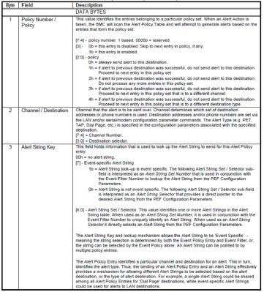

The IBMC FW reserves 40 alert policy entries. The default value is showed in below table.(TBD)

 | Table 2-8 Alert Policy Default
HON HAI Precision Industry Co., Ltd. | Doc. No.
CESBG R&D Division Server | Rev.1.1Page 18/54

 | Twins BMC Firmware Specification
Alert Policy Entry Number | Setting
1 | 0x10 0x10 0x81
2 | 0x10 0x10 0x81
3 | 0x10 0x10 0x81
4 | 0x10 0x10 0x81
5 | 0x10 0x10 0x81
6 | 0x10 0x10 0x81
…… | ……

Alert String Key:

- – 1b = Alert String look-up is event specific, and it will be searched in PEF configuration parameter 12#

– 0b = Alert String look-up is event not specific, and it will be searched in PEF configuration parameter 13#

2.5.2.Alert String Keys and Alert Strings (TBD)

The IBMC FW reserves 40 sets of alert string keys and strings. The default value is showed in below table.

Table 2-9 Alert String Keys and Strings

Selector | Alert String | Alert String (48Bytes, 3 Blocks)
Number | key | Alert String (48Bytes, 3 Blocks)
1 | 0 0 | N/A
2 | 0 0 | N/A
3 | 0 0 | N/A
4 | 0 0 | N/A
5 | 0 0 | N/A
6 | 0 0 | N/A
7 | 0 0 | N/A
8 | 0 0 | N/A
… | … | …

2.5.3.PEF Action PEF Action

The IBMC FW supports the following PEF actions:
- Power off

- Power cycle

- Reset

- Alerts

- NMI

The IBMC FW provides an IPMI type sensor 02h, system event, for the PEF action. This sensor is disabled by default.

Please refer to the PEF configuration parameters.

HON HAI Precision Industry Co., Ltd. | Doc. No.
CESBG R&D Division Server | Rev.1.1Page 19/54

Twins BMC Firmware Specification

2.5.4.Event Processing When the SEL Is Full

If the SEL is full and Event Message Buffer is enabled, new events could still be put into the buffer. Up to 10 event messages can be stored in the buffer at a time. The Event Message Buffer for IPMI v1.5 is not overwritten if new events come in. Therefore, if the Event Message Buffer is full, further events will not go into the event message buffer until it’s cleared.

“Get BMC global enables” command can be used to retrieve the present setting of Event Message Buffer enables. “Set BMC global enables” command can be used to enable the buffer.

2.6.FRU

FRU data will be available in IPMI FRU format through the IPMI FRU Commands. The FRU storage area will be located in a special EEPROM chip connected to BMC through I2C bus. The system FRU information should be provided via FRU Device ID and the access information will be defined as below:

2.6.1.FRU Devices & Access Information

IPMI provides FRU information in two ways: via an IBMC, or via FRU SEEPROMs. FRU information that is managed by an IBMC is accessed using IPMI commands. In this project, FRU information is stored in SEEPROMs. The SEEPROM information is shown below,

Table 2-10 FRU Devices

FRU Device ID | Description | I2C Bus ID | Slave Address | Base Offset
0x00 | System FRU | 0X09(*1) | 0xA0 | 0x0000

Note: 1. I2C bus ID is the 1st request data byte of Master Write-Read command.

2.6.2.FRU Byte Definition

FRU data byte definition follows FRU spec V1.0. The FRU information for Twins project can be refer to Appendix D

2.7.SOL

The IBMC FW supports IPMI 2.0 SOL. SOL sessions are only supported on serial port 2 (COM2).

IPMI 2.0 introduced a standard serial-over-LAN feature. This is implemented as a standard payload type (01h) over RMCP+.

Three commands are implemented for SOL 2.0 configuration:

- “Get SOL 2.0 Configuration Parameters” and “Set SOL 2.0 Configuration Parameters”: These commands are used to get and set the values of the SOL configuration parameters. The parameters are implemented on a per-channel

basis. See Table 52.
- “Activating SOL”: This command is not accepted by the BMC. It is sent by the BMC when SOL is activated, to notify

HON HAI Precision Industry Co., Ltd. | Doc. No.
CESBG R&D Division Server | Rev.1.1Page 20/54

Twins BMC Firmware Specification

a remote client of the switch to SOL.

Activating a SOL session requires an existing IPMI-over-LAN session. If encryption is used, it should be negotiated when the IOL session is established. 02

Note: The function keys and keypad setting of tool using should compatible with the setting in BIOS.

 | You can manually input unsupported
keystrokes by entering escape sequences.
 | ESC+2 |  | F2
 | ESC+7 |  | F7
 | ESC+@ |  | F12
 |  |  | Table 2-11 SOL Configuration Parameters
 | Parameter Name |  |  | # |  | Default Value
 | SOL Enable |  |  | 1 | 01 – SOL payload enabled
 | SOL Authentication |  |  | 2 | 84h
 |  |  |  |  | [7] = 1b – Force Encryption
 |  |  |  |  | [6] = 0b – Authentication controlled by remote software
 |  |  |  |  | [3:0] = 04h – Administrator level
 | Character Accumulate Interval & |  |  | 3 | 0Ch 60h
 | Character Send Threshold
 | SOL Retry |  |  | 4 | 07h | 32h
 | SOL NV bit rate |  |  | 5 | 06h | –115.2kbps
 | (non-volatile)
 | SOL volatile bit rate (volatile) |  |  | 6 | 06h | – 115.2 kbps
 | SOL Payload Channel |  |  | 7 | 01h
 | (optional, Read Only)
 | SOL Payload Port Number (Read Only |  |  | 8 | 6Fh 02h – 26Fh
 | or Read/Write – see description)

2.8.1FIRMWARE UPDATE

2.8.1.BMC FW

2.8.1.1.Update via Web GUI

The steps of FW update via Web GUI are showed below.

- Log into Web GUI via Web Browser

- Select “Maintenance” -> "Firmware Update" menu of the left view menu

- Choose the “Preserve all configuration” on the checkbox if all configurations need to be preserved.

- “Select Firmware Image” to select the BMC FW image.

HON HAI Precision Industry Co., Ltd. | Doc. No.
CESBG R&D Division Server | Rev.1.1Page 21/54

Twins BMC Firmware Specification

- Click “Start Firmware Update”

- Choose “Flash selected section” (Default is all) to start BMC FW update.

- After BMC FW is updated, system will pop up a message.
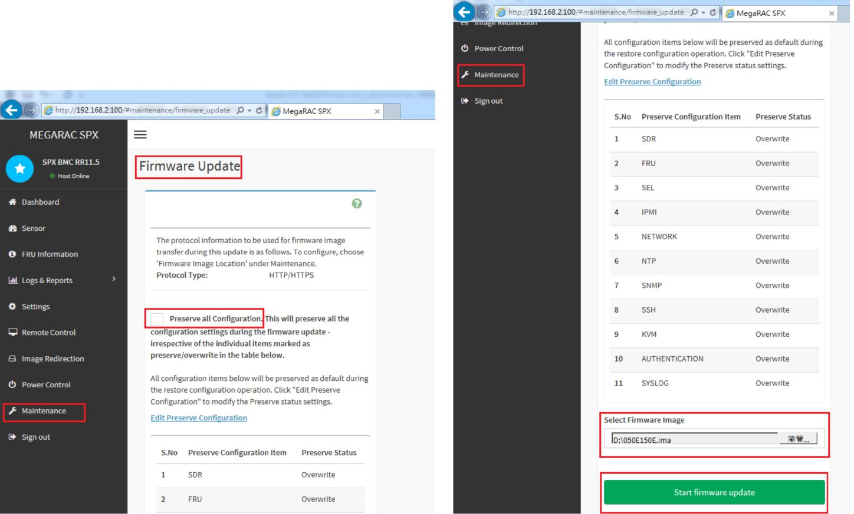

Figure 2-1-1 Figure 2-1-2

HON HAI Precision Industry Co., Ltd. | Doc. No.
CESBG R&D Division Server | Rev.1.1Page 22/54

Twins BMC Firmware Specification
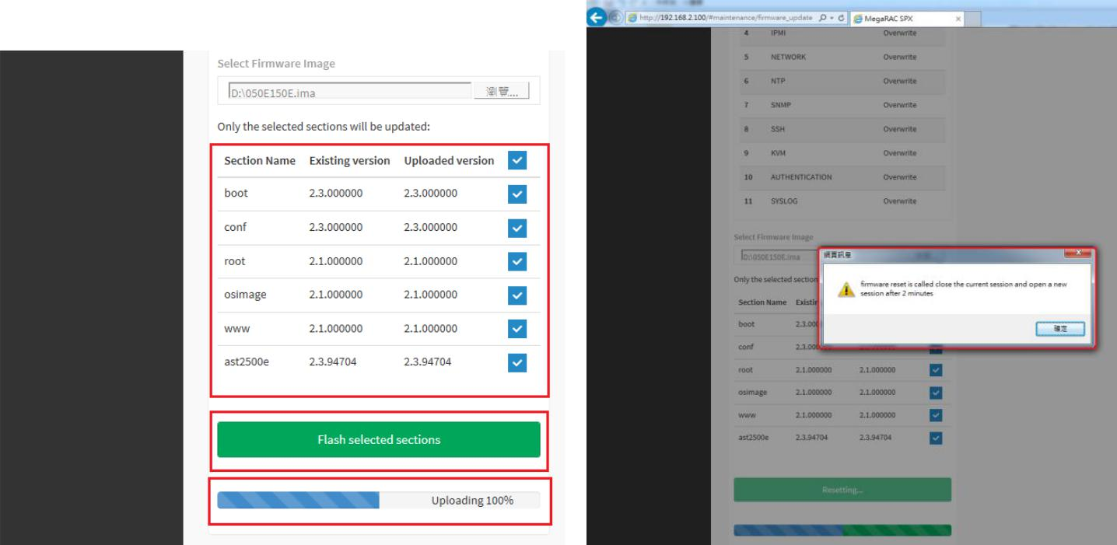

Figure 2-1-3 Figure 2-1-4

Figure 2-1 Firmware Update via WebUI

2.8.1.2.Update Utilities of AMI

FW update utilities of AMI, named Yafuflash, are used to perform IBMC firmware update under UEFI, Linux 32/64bits.

2.8.1.3.Update Utilities of Aspeed

FW update utilities of Aspeed, named socflash, are used to do engineering validation only, and UEFI, Linux 32/64bits are supported. The latest socflash can be download from the Web site of Aspeed.

Note: Socflash uses rom file to update firmware, and it will restore default configuration always.

2.8.2.Others

Table 2-12 Supported FW update lists

Items | Supported |  |  | Comments
BMC FW | V | Refer to Sec.2.8.1
BIOS FW image | V
(including BIOS/ME/Gbe….)
CPLD FW image
VR FW image
PSU FW image

HON HAI Precision Industry Co., Ltd. | Doc. No.
CESBG R&D Division Server | Rev.1.1Page 23/54

Twins BMC Firmware Specification

2.9.WEB GUI

Web GUI is a friendly interface for the end users. Users can access the IBMC FW via a HTML5 supported web browser, and then can go through the server status and do many configurations to the IBMC FW. Web user privilege only allows administrator initially.

2.9.1.Specification

Please refer to IBMC FW Web GUI specification, Twins_BMC_WebGUI_Spec-V0.1-20170126.pdf

2.9.2.Supported Web Browser

The IBMC FW can support below Web Browser (Recommend using the latest version):
- Microsoft IE

- Firefox

- Chrome (Recommended)

2.10.WATCHDOG TIMER ACTIONS

The following actions are supported on expiration of the Watchdog Timer:
- System Reset

- System Power Off

- System Power Cycle

2.10.1.Pre-timeout Interrupt

The Watchdog Timer offers a ‘Pre-timeout Interrupt’ option. This option is enabled whenever the ‘Interrupt on timeout’ option is selected coincident with any of the other Watchdog Timer actions.

2.10.2.Watchdog Timer Event Logging

By default, the BMC will automatically log the corresponding sensor-specific watchdog sensor event when a timer expiration occurs. A “don’t log” bit is provided to temporarily disable the automatic logging. The “don’t log” bit is automatically cleared (logging re-enabled) whenever a timer expiration occurs.

2.10.3.Common Usage in System

- BIOS FRB2 Timeout: An FRB-2 (fault-resilient booting, level 2) timeout has occurred. This indicates that the last system reset or power cycle was due to the system timeout during POST, presumed to be caused by a failure or

hang related to the bootstrap processor. The timeout interval can be set in BIOS setup menu.

- OS Load Timeout: The last reset or power cycle was caused by the timer being used to ‘watchdog’ the interval from ‘boot’ to OS up and running. This mode requires system management software, or OS support. BIOS should

starts this timer after POST completes, and clear this flag if it starts this timer during POST. The timeout interval can be set in BIOS setup menu.

HON HAI Precision Industry Co., Ltd. | Doc. No.
CESBG R&D Division Server | Rev.1.1Page 24/54

Twins BMC Firmware Specification

SMS “OS Watchdog” Timeout: This indicates that the timer was being used by System Management Software. During run-time, System Management Software (SMS) starts the timer, and then periodically resets it to keep it from expiring. This periodic action serves as a ‘heartbeat’ that indicates that the OS (or at least the SMS task) is still functioning. If OS and SMS hang, the timer expires and the IBMC FW generates a system reset. This is also called ASR (Auto Server Restart). When SMS enables the timer, it should make sure the ‘SMS’ bit is set to indicate that the timer is being used in its ‘OS Watchdog’ role.

2.10.4.HW WDT for IBMC

After a programmable counter counts down to zero, a system reset signal is generated to reset BMC or full chip. (TBD)

2.11.SERIAL REDIRECTION

The system can take control of the shared serial port to perform text console redirection. Additionally, the IBMC FW can be configured to capture the host serial port traffic and redirect it to the system network controller via RMCP+ messages. This enables remote management via a serial over LAN (SOL) interface.

2.11.1.KVM Redirection

The IBMC firmware supports keyboard, video, and mouse redirection (KVM) over LAN. This feature is available remotely from the embedded Web GUI as a Java applet. This feature requires that Java 1.5.7 or later is installed on the host system. Java Web Start 1.6 is required to launch the KVM over an IPv6 network. The features of KVM is listed below.

- Converts the analog keyboard, video and mouses(KVM) signals into digital packets, compressing them and transmitting them securely over TCP/IP connections.

- Requirements:(TBD)

– Performance, bandwidth, frame per second
- DVC, buffered/un-buffered core

– Maximum resolution
- Support the following host resolutions:

– 1280 x 1024 @ 60 Hz

– 1024 x 768 @ 60, 72, 75 and 85 Hz

– 800 x 600 @ 60, 72, 75 and 85 Hz

– 640 x 480 @ 60, 72, 75 and 85 Hz
- Provide two levels of video quality:

– YUV420 – lower quality and higher compression

– YUV444 – higher quality and lower compression (this mode requires more processor time and network bandwidth)

HON HAI Precision Industry Co., Ltd. | Doc. No.
CESBG R&D Division Server | Rev.1.1Page 25/54

Twins BMC Firmware Specification

Note: There is 1 virtual USB keyboard, and there are 2 virtual USB mice for KVM function: one mouse is for Windows, and the other is for Linux. These virtual USB devices will always exist during BMC firmware life time.

2.12.FSC (FAN SPEED CONTROL)

IBMC FW will implement the FSC table provided by thermal team.

2.12.1.Sensors and Fans

The FSC supports max of 5 fan profiles. Each sensor set is mapping to each fan profile.

Table 2-13 Sensors and Fan actions

 | Sensor Name |  | Sensor |  | Actions |  | Supported
 | Ambient Sensor |  | On board Ambient sensor |  | Open loop profiles |  | V
 | CPU |  | CPU0,CPU1_System Detected |  |  |  | V
 | DIMM |  | DIMM Internal chip sensor |  | Close loop profiles |  | V
 | PCH |  | PCH Internal chip sensor |  | Close loop profiles |  | V
 | PCIe |  | PCIe card temperature sensor |  |  |  | TBD

2.12.2.Open Loop Control Policy

Expected PWM duty cycle of fan speed is depended on the ambient sensor, and follows following formula.

PWM Duty cycle (%) = a*Sys Amb^2+b*Sys Amb( C )+c.
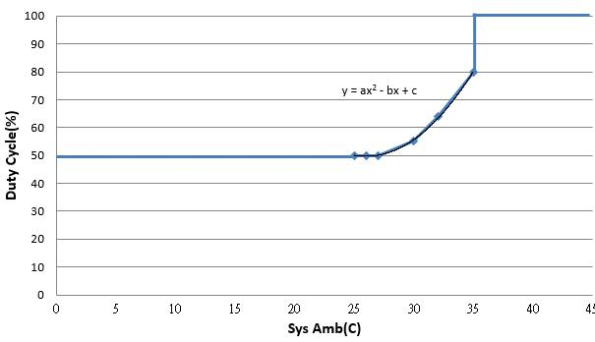

Figure 2-2 Open loop policy

2.12.3.Close Loop Control Policy

Expected PWM duty cycle of fan speed is depended on related sensors, and follows following flow chart.

HON HAI Precision Industry Co., Ltd. | Doc. No.
CESBG R&D Division Server | Rev.1.1Page 26/54

Twins BMC Firmware Specification
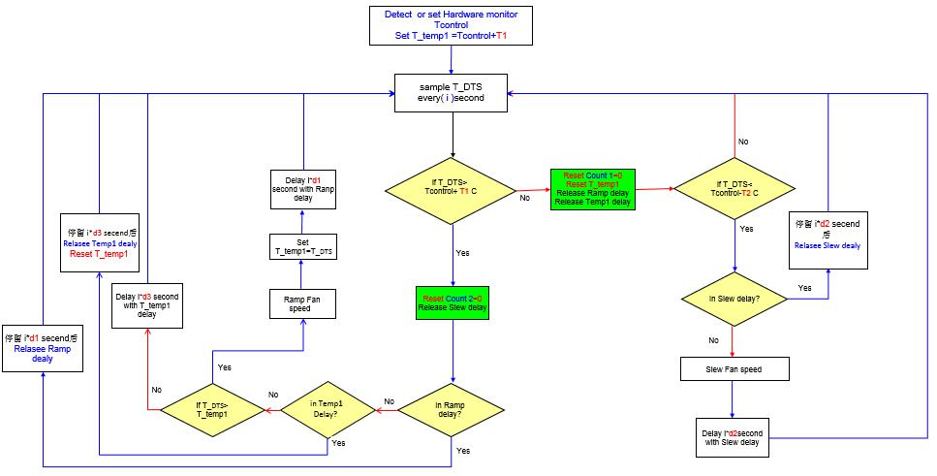

Figure 2-3 Close loop control policy

2.12.4.Threshold Definition

The FSC table defines in which temperature IBMC should alert/de-alert SEL events or let system shut down to avoid thermal damage. Below table is a threshold definition example.

Table 2-14 Sensor Threshold Definitions

Sensor Items | Normal | UNC(*1) | UC(*2) | Shutdown
CPU | <-3 | -3 | -1 | NA
DIMM | <83 | 83 | 85 | NA
PCH | <90 | 90 | 92 | NA
System Ambient | <35 | 35 | 38 | NA

Note: 1 UNC: Upper Non-Critical

2. UC: Upper Critical

2.13.SECURITY

2.13.1.firmware firewall

The IBMC FW can support Firmware Firewall. Firmware firewall is an IPMIv2.0 optional capability that is supported on all iBMC implementations. Details can be found in the IPMIv2.0 specification Chapter 21.

Firmware firewall implements three basic categories of commands for the purposes of preventing inadvertent or malicious access to the IBMC or system.

- The first category provides external software to query which commands are supported, known as “command discovery commands”.

- The second category allows queries of which commands can be enabled or disabled, known as “configurable

HON HAI Precision Industry Co., Ltd. | Doc. No.
CESBG R&D Division Server | Rev.1.1Page 27/54

Twins BMC Firmware Specification

command discovery”.

- The final category allows configurable commands to be enabled or disabled. By default, all supported commands are enabled in the BMC implementations.

2.14.VIRTUAL MEDIA

Virtual Media allows a floppy image, floppy drive or CD/DVD drive on your system, to be available on the managed system's console as if the floppy image or drive were present on the local system. For example, after you virtualize a drive on a managed system running the Microsoft(R) Windows(R) operating system, the virtualized drive appears in Windows Explorer as a real drive with a new drive letter (for example, G:).
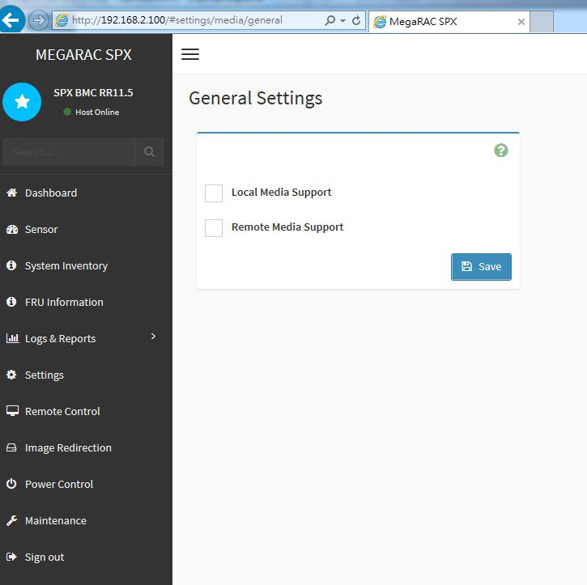

Figure 2-4 Virtual Media

Note: All virtual USB devices (excluding the keyboard and mouse) will not mount to the host system until the end user opens the virtual media session from Web GUI.

2.15.SMASH-CLP

SMASH-CLP sessions to the IBMC FW could be supported by Secure Shell (SSH) connection.

2.16.IBMC FIRMWARE AND BIOS INTERFACE

BIOS is able to communicate with IBMC FW via KCS interface over the LPC bus. The I/O base address is defined in system interface.

HON HAI Precision Industry Co., Ltd. | Doc. No.
CESBG R&D Division Server | Rev.1.1Page 28/54

Twins BMC Firmware Specification

Table 2-15 BIOS and FW Interface

BIOS Function |  | Sub-function |  | IPMI CMD Implementation (HEX)
Send real time clock data | / |  |  | Set SEL Time (0A, 49)
during post
IBMC initial health check | / |  |  | Get Self Test Results (06, 04)
and report status
Show IBMC firmware | / |  |  | Get Device ID (06, 01)
information
Maintain and control | /
system GUID and provide it |  |  |  | Set System GUID (2E, CC) (OSA CMD)
to IBMC during POST
BIOS POST phase: Log |  | System firmware error/hang
Failure Alerts for |  | Memory error/event
firmware/hardware error or |  | Processor error/event
event check |  | PCI error/event
 |  | Memory correctable or
 |  | uncorrectable errors
 |  | PCI PERR/SERR errors |  | Platform Event (04, 02)
Operating system running |  | Processor correctable or |  | PEF Table
Operating system running |  | uncorrectable machine check
phase: log system event or |  | uncorrectable machine check
phase: log system event or |  | errors
error by SMI handler |  | errors
error by SMI handler |  | System/platform specific event
 |  | (Pecos cable fail-over, memory
 |  | hot add, hot replace, and
 |  | hot spare events and errors)
 |  | Log new SEL entry |  | Add SEL Entry (0A, 44)
System Event Log (SEL) |  | Get SEL enty |  | Get SEL Entry (0A, 43)
System Event Log (SEL) |  | Delete SEL entry
Access |  | Delete SEL entry |  | Reserve SEL (0A, 42)
 |  |  |  | Clear SEL (0A, 47)
System VPD Access | / |  |  | Master read-write (06, 52)
 |  | IP Address(3)
 |  | IP Source(4)
IBMC LAN Configuration |  | MAC Address(5) |  | Get/Set LAN Configuration (0C, 01/02)
 |  | Subnet Address(6)
 |  | Gateway Address(12)
POST/OS Loader Watchdog |  | Start/Stop Watchdog Time |  | Set Watchdog Timer (06, 24)
Timer support |  | Reset Watchdog Timer |  | Reset Watchdog Timer (06, 22)
 |  | Enable/Disable serial port sharing |  | Get/Set Serial/modem configuration (0C,
 |  | (Parameter 8)
COM port sharing for serial |  | (Parameter 8) | 10/11)
COM port sharing for serial |  | Destination COM Setting(19)
redirection |  | Destination COM Setting(19)
redirection |  | Set/Get serial channel access |  | Set/Get Channel Access (06, 40/41)
 |  | MUX Switch Control |  | Set Serial/modem MUX (0C, 12)
System/Chassis boot | / |  |  | Get/Set System Boot Options (00, 08/09)
control

HON HAI Precision Industry Co., Ltd. | Doc. No.
CESBG R&D Division Server | Rev.1.1Page 29/54

Twins BMC Firmware Specification

CHAPTER 3. CUSTOMERS FEATURES

3.1.CUSTOMERS’ FEATURE SUPPORT LIST

Table 3-1 Customers’ Features


Items | Functions | Supported | Remark

Document:

1

3.2.BMC FIRMWARE NAMING

The BMC firmware name can be discovered by using the mandatory Get Device ID command and shown on WebUI.

Detail data is shown in Appendix G. For the Twins platform, the auxiliary firmware revision is shown below.

Table 3-2 Auxiliary firmware revision for the Twins platform

Phase | Auxiliary firmware revision
EVT | 0xE614251D
DVT | 0xE614251D
PVT | 0xE614251D
Production | 0xE614251D
Maintenance | 0xE614251D

HON HAI Precision Industry Co., Ltd. | Doc. No.
CESBG R&D Division Server | Rev.1.1Page 30/54

Twins BMC Firmware Specification

APPENDIX A IBMC HARDWRE: AST2500

AST2500 is the 6th generation of Integrated Remote Management Processor introduced by ASPEED Technology Inc. Its a vastly integrated SOC device playing as a service processor to support various functions required for highly manageable server platforms. Instead of supporting PCI bus, AST2500 is designed to dedicatedly support PCIE Gen2 1x bus interface, which can make PCB layout simpler and fit systems that are going without PCI bus support. The chip architecture is showed below:
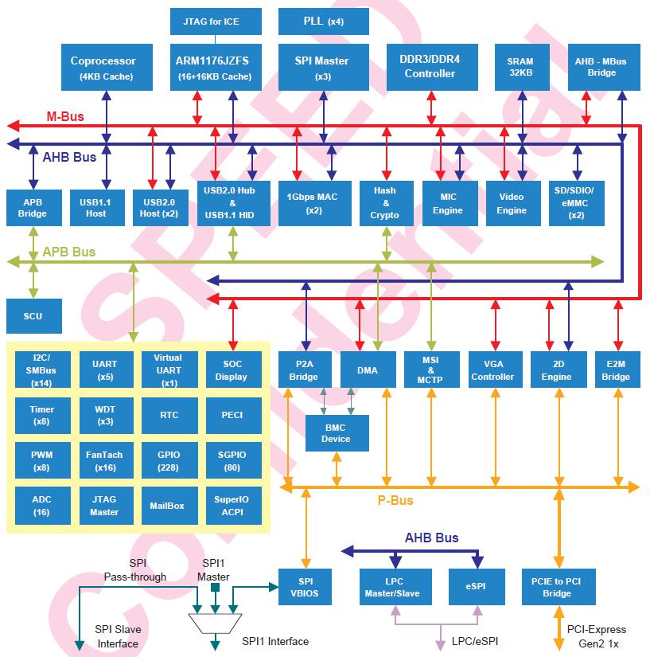

Figure A-1 AST2500 Chip architecture

The following list is a summary of the IBMC management hardware features utilized by the IBMC:
- 800-MHz ARM1176JZF-S 32-bit RISC CPU

HON HAI Precision Industry Co., Ltd. | Doc. No.
CESBG R&D Division Server | Rev.1.1Page 31/54

Twins BMC Firmware Specification

- Embedded one more 32-bit Coprocessor RISC CPU except the ARM. Max. 200MHz.

- Built-in PCIE 2.0 Bridge Controller & PCIe Gen 2 PHY

- Built-in PCI-Express 2.0 Root Complex or End Point Controller & PCI-Express Gen 2 PHY

- VGA Display Controller

- Graphics Display Controller

- Video Compression Engine

- Two 10/100/1000 Ethernet controllers with NC-SI support

- 16-bit DDR3L/DDR4 800MHz interface

- 36KB internal SRAM

- System Control Unit

- AHB controller

- Interrupt Controller

- Firmware SPI Memory Controller

- SPI Master Controller

- SD/SDIO/eMMC Host controller

- USB2.0 Vitual Hub Controller

- 64-bit 2D Graphics Accelerator

- 14 sets of multi-function I2C/SMBus bus controller

- Support up to 228 GPIO pins

- Support up to 80 SGPIO input ports

- Slave serial GPIO monitor

- 16 fan tachometers

- 8 PWMs

- KCS interface

- 5 sets of 16550 UART controllers. 921.K baud-rate. Support Hardware UART debug

- Built-in 8 sets of 32-bit timer modules

- 2 sets of USB 2.0 for keyboard, mouse, and storage devices

- 3 sets of 32-bit Watchdog timer

- 64 bytes Battery backed SRAM

- LPC Bus Interface

- eSPI interface

- System SPI Flash Controller

- Super I/O controller

- Hash & Crypto Engine

- Memory Integrity Check(MIC)Engine

- 16 sets of 10 bits ADC channel pins

HON HAI Precision Industry Co., Ltd. | Doc. No.
CESBG R&D Division Server | Rev.1.1Page 32/54

Twins BMC Firmware Specification

- Intel PECI 3.1 Compliant

- JTAG master

- MCTP controller

- MSI controller

- X-DMA controller

The more information can refer to the Datasheet of AST2500.

HON HAI Precision Industry Co., Ltd. | Doc. No.
CESBG R&D Division Server | Rev.1.1Page 33/54

Twins BMC Firmware Specification

APPENDIX B IPMI COMMANDS SUPPORT TABLE

All option commands and all option parameters of mandatory commands in the command list below are not insured for supporting. Some mandatory commands may be not supported according to FW PRD.
 | Command |  | NetFn |  | CMD |  | M/ |  | Supported |  | Comments
 | Command |  | NetFn |  | CMD |  | O
 | IPMI Device “Global” Commands
 | Get Device ID |  | App |  | 01h |  | M |  | V
 | Broadcast ‘Get Device ID’[1] |  | App |  | 01h |  | M
 | Cold Reset |  | App |  | 02h |  | O |  | V
 | Warm Reset |  | App |  | 03h |  | O |  | V
 | Get Self Test Results |  | App |  | 04h |  | M |  | V
 | Manufacturing Test On |  | App |  | 05h |  | O |  | V |  | need password
 | Set ACPI Power State |  | App |  | 06h |  | O |  | V
 | Get ACPI Power State |  | App |  | 07h |  | O |  | V
 | Get Device GUID |  | App |  | 08h |  | O |  | V
 | Get NetFn Support |  | App |  | 09h |  | O |  | V
 | Get Command Support |  | App |  | 0Ah |  | O |  | V
 | Get Command Sub-function Support |  | App |  | 0Bh |  | O |  | V
 | Get Configurable Commands |  | App |  | 0Ch |  | O |  | V
 | Get Configurable Command |  | App |  | 0Dh |  | O |  | V
 | Sub-functions |  | App |  | 0Dh |  | O |  | V
 | Set Command Enables |  | App |  | 60h |  | O
 | Get Command Enables |  | App |  | 61h |  | O |  | V
 | Set Command Sub-function Enables |  | App |  | 62h |  | O
 | Get Command Sub-function Enables |  | App |  | 63h |  | O
 | Get OEM NetFn IANA Support |  | App |  | 64h |  | O |  | V
 | BMC Watchdog Timer Commands
 | Reset Watchdog Timer |  | App |  | 22h |  | M |  | V
 | Set Watchdog Timer |  | App |  | 24h |  | M |  | V
 | Get Watchdog Timer |  | App |  | 25h |  | M |  | V
 | BMC Device and Messaging
 | Commands
 | Set BMC Global Enables |  | App |  | 2Eh |  | M |  | V |  | "Only Supported: SEL Logging Enable / Disable,
 | Set BMC Global Enables |  | App |  | 2Eh |  | M |  | V |  | Event message buffer Enable/disable"
 | Get BMC Global Enables |  | App |  | 2Fh |  | M |  | V
 | Clear Message Flags |  | App |  | 30h |  | M |  | V
 | Get Message Flags |  | App |  | 31h |  | M |  | V
 | Enable Message Channel Receive |  | App |  | 32h |  | O |  | V
 | Get Message |  | App |  | 33h |  | M |  | V
 | Send Message |  | App |  | 34h |  | M |  | V |  | not support Send Raw
 | Read Event Message Buffer |  | App |  | 35h |  | O |  | V
 | Get BT Interface Capabilities |  | App |  | 36h |  | O |  | V
 | Get System GUID |  | App |  | 37h |  | O |  | V
 | Get Channel Authentication |  | App |  | 38h |  | O |  | V
 | Capabilities |  | App |  | 38h |  | O |  | V
 | Get Session Challenge |  | App |  | 39h |  | O |  | V
 | Activate Session |  | App |  | 3Ah |  | O |  | V
 | Set Session Privilege Level |  | App |  | 3Bh |  | O |  | V
 | Close Session |  | App |  | 3Ch |  | O |  | V
 | Get Session Info |  | App |  | 3Dh |  | O |  | V
 | Get AuthCode |  | App |  | 3Fh |  | O |  | V
 | Set Channel Access |  | App |  | 40h |  | M |  | V |  | "Only support: disabled, always availible, shared
 | Set Channel Access |  | App |  | 40h |  | M |  | V |  | mode"
 | Get Channel Access |  | App |  | 41h |  | M |  | V
HON HAI Precision Industry Co., Ltd. |  |  |  |  |  |  |  |  |  |  | Doc. No.
CESBG R&D Division Server |  |  |  |  |  |  |  |  |  |  | Rev.1.1 | Page 34/54

Twins BMC Firmware Specification

 | Get Channel Info Command |  |  | App |  | 42h |  | O |  | V
 | Set User Access Command |  |  | App |  | 43h |  | O |  | V |  | Not support user session limit
 | Get User Access Command |  |  | App |  | 44h |  | O |  | V
 | Set User Name |  |  | App |  | 45h |  | O |  | V
 | Get User Name Command |  |  | App |  | 46h |  | O |  | V
 | Set User Password Command |  |  | App |  | 47h |  | O |  | V
 | Activate Payload |  |  | App |  | 48h |  | O |  | V
 | Deactivate Payload |  |  | App |  | 49h |  | O |  | V
 | Get Payload Activation Status |  |  | App |  | 4Ah |  | O |  | V
 | Get Payload Instance Info |  |  | App |  | 4Bh |  | O |  | V
 | Set User Payload Access |  |  | App |  | 4Ch |  | O |  | V
 | Get User Payload Access |  |  | App |  | 4Dh |  | O |  | V
 | Get Channel Payload Support |  |  | App |  | 4Eh |  | O |  | V
 | Get Channel Payload Version |  |  | App |  | 4Fh |  | O |  | V
 | Get Channel OEM Payload Info |  |  | App |  | 50h |  | O |  | V
 | Master Write-Read |  |  | App |  | 52h |  | M |  | V
 | Get Channel Cipher Suites |  |  | App |  | 54h |  | O |  | V
 | Suspend/Resume Payload |  |  | App |  | 55h |  | O |  | V
 | Encryption |  |  | App |  | 55h |  | O |  | V
 | Set Channel Security Keys |  |  | App |  | 56h |  | O |  | V
 | Get System Interface Capabilities |  |  | App |  | 57h |  | O |  | V |  | Only 01h(KCS) is supported
 | Set System Info Parameters |  |  | App |  | 58h |  | O |  | V
 | Get System Info Parameters |  |  | App |  | 59h |  | O |  | V
 | Chassis Device Commands
 | Get Chassis Capabilities |  |  | Chassis |  | 00h |  | M |  | V
 | Get Chassis Status |  |  | Chassis |  | 01h |  | M |  | V
 | ChassisControl |  |  | Chassis |  | 02h |  | M |  | V
 | Chassis Reset |  |  | Chassis |  | 03h |  | O |  |  |  | This command is combined to Chassis Control
 |  |  |  | Chassis |  | 03h |  | O |  |  |  | command in IPMI v1.5
 | Chassis Identify |  |  | Chassis |  | 04h |  | O |  | V
 | Set Chassis Capabilities |  |  | Chassis |  | 05h |  | O |  | V
 | Set Power Restore Policy |  |  | Chassis |  | 06h |  | O
 | Get System Restart Cause |  |  | Chassis |  | 07h |  | O |  | V |  | Only 01h (cycle,hardware reset), 04h,8h,9h
 |  |  |  | Chassis |  | 07h |  | O |  | V |  | supported
 | Set System Boot Options |  |  | Chassis |  | 08h |  | O |  | V
 | Get System Boot Options |  |  | Chassis |  | 09h |  | O |  | V
 | Set Front Panel Button Enables |  |  | Chassis |  | 0Ah |  | O
 | Set Power Cycle Interval |  |  | Chassis |  | 0Bh |  | O |  | V
 | Get POH Counter |  |  | Chassis |  | 0Fh |  | O |  | V
 | Event Commands
 | Set Event Receiver |  |  | S/E |  | 00h |  | M |  | V
 | Get Event Receiver |  |  | S/E |  | 01h |  | M |  | V
 | Platform Event (a.k.a. “Event |  |  | S/E |  | 02h |  | M |  | V
 | Message”) |  |  | S/E |  | 02h |  | M |  | V
 | PEF and Alerting Commands
 | Get PEF Capabilities |  |  | S/E |  | 10h |  | M |  | V
 | Arm PEF Postpone Timer |  |  | S/E |  | 11h |  | M |  | V
 | Set PEF Configuration Parameters |  |  | S/E |  | 12h |  | M |  | V |  | Does not support parameter | 15.
 | Get PEF Configuration Parameters |  |  | S/E |  | 13h |  | M |  | V |  | Does not support parameter | 15.
 | Set Last Processed Event ID |  |  | S/E |  | 14h |  | M |  | V
 | Get Last Processed Event ID |  |  | S/E |  | 15h |  | M |  | V
 | Alert Immediate |  |  | S/E |  | 16h |  | O |  | V
 | PET Acknowledge |  |  | S/E |  | 17h |  | O |  | V
 | Sensor Device Commands
 | Get Device SDR Info |  |  | S/E |  | 20h |  | O |  | V
 | Get Device SDR |  |  | S/E |  | 21h |  | O |  | V
 | Reserve Device SDR Repository |  |  | S/E |  | 22h |  | O |  | V
HON HAI Precision Industry Co., Ltd. |  |  |  |  |  |  |  |  |  |  |  | Doc. No.
CESBG R&D Division Server |  |  |  |  |  |  |  |  |  |  |  | Rev.1.1 | Page 35/54

Twins BMC Firmware Specification

 | Get Sensor Reading Factors |  |  | S/E |  | 23h |  | O |  | V |  | Support linear sensors only.
 | Set Sensor Hysteresis |  |  | S/E |  | 24h |  | O |  | V
 | Get Sensor Hysteresis |  |  | S/E |  | 25h |  | O |  | V
 | Set Sensor Threshold |  |  | S/E |  | 26h |  | O |  | V
 | Get Sensor Threshold |  |  | S/E |  | 27h |  | O |  | V
 | Set Sensor Event Enable |  |  | S/E |  | 28h |  | O |  | V
 | Get Sensor Event Enable |  |  | S/E |  | 29h |  | O |  | V
 | Re-arm Sensor Events |  |  | S/E |  | 2Ah |  | O |  | V
 | Get Sensor Event Status |  |  | S/E |  | 2Bh |  | O |  | V
 | Get Sensor Reading |  |  | S/E |  | 2Dh |  | M |  | V
 | Set Sensor Type |  |  | S/E |  | 2Eh |  | O |  | V
 | Get Sensor Type |  |  | S/E |  | 2Fh |  | O |  | V
 | Set Sensor Reading and Event Status |  |  | S/E |  | 30h |  | O |  | V |  | Sensor should be settable (just for FW engineer
 |  |  |  | S/E |  | 30h |  | O |  | V |  | debug purpose internally)
 | FRU Device Commands
 | Get FRU Inventory Area Info |  |  | Storage |  | 10h |  | M |  | V
 | Read FRU Data |  |  | Storage |  | 11h |  | M |  | V
 | Write FRU Data |  |  | Storage |  | 12h |  | M |  | V
 | SDR Device Commands
 | Get SDR Repository Info |  |  | Storage |  | 20h |  | M |  | V
 | Get SDR Repository Allocation |  |  | Storage |  | 21h |  | O |  | V
 | Reserve SDR Repository |  |  | Storage |  | 22h |  | M |  | V
 | Get SDR |  |  | Storage |  | 23h |  | M |  | V
 | Add SDR |  |  | Storage |  | 24h |  | O |  | V
 | Partial Add SDR |  |  | Storage |  | 25h |  | M |  | V
 | Delete SDR |  |  | Storage |  | 26h |  | O
 | Clear SDR Repository |  |  | Storage |  | 27h |  | M |  | V
 | Get SDR Repository Time |  |  | Storage |  | 28h |  | O |  | V
 | Set SDR Repository Time |  |  | Storage |  | 29h |  | O
 | Enter SDR Repository Update |  |  | Storage |  | 2Ah |  | O
 | Exit SDR Repository Update |  |  | Storage |  | 2Bh |  | O
 | Run Initialization Agent |  |  | Storage |  | 2Ch |  | O |  | V
 | SEL Device Commands
 | Get SEL Info |  |  | Storage |  | 40h |  | M |  | V
 | Get SEL Allocation Info |  |  | Storage |  | 41h |  | O |  | V
 | Reserve SEL |  |  | Storage |  | 42h |  | O |  | V
 | Get SEL Entry |  |  | Storage |  | 43h |  | M |  | V
 | Add SEL Entry |  |  | Storage |  | 44h |  | M |  | V
 | Partial Add SEL Entry |  |  | Storage |  | 45h |  | O |  | V
 | Delete SEL Entry |  |  | Storage |  | 46h |  | O |  | V
 | Clear SEL |  |  | Storage |  | 47h |  | M |  | V
 | Get SEL Time |  |  | Storage |  | 48h |  | M |  | V
 | Set SEL Time |  |  | Storage |  | 49h |  | M |  | V
 | Get Auxiliary Log Status |  |  | Storage |  | 5Ah |  | O
 | Set Auxiliary Log Status |  |  | Storage |  | 5Bh |  | O
 | Get SEL Time UTC Offset |  |  | Storage |  | 5Ch |  | O |  | V
 | Set SEL Time UTC Offset |  |  | Storage |  | 5Dh |  | O |  | V
 | LAN Device Commands
 | Set LAN Configuration Parameter |  |  | Transport |  | 01h |  | M |  | V |  | param #9, 25 are not support
 | Get LAN Configuration Parameters |  |  | Transport |  | 02h |  | M |  | V |  | param #9, 25 are not support
 | Suspend BMC ARPs |  |  | Transport |  | 03h |  | O |  | V
 | Get IP/UDP/RMCP Statistics |  |  | Transport |  | 04h |  | O
 | Serial/Modem Device Commands
 | Set Serial/Modem Configuration |  |  | Transport |  | 10h |  | M |  | V
 | Get Serial/Modem Configuration |  |  | Transport |  | 11h |  | M |  | V
 | Set Serial/Modem Mux |  |  | Transport |  | 12h |  | O |  | V
 | Get TAP Response Codes |  |  | Transport |  | 13h |  | O
HON HAI Precision Industry Co., Ltd. |  |  |  |  |  |  |  |  |  |  |  | Doc. No.
CESBG R&D Division Server |  |  |  |  |  |  |  |  |  |  |  | Rev. | 1.1 | Page 36/54

 |  |  |  |  |  |  | Twins BMC Firmware Specification
Set PPP UDP Proxy Transmit |  |  | Transport |  | 14h |  | O
Get PPP UDP Proxy Transmit |  |  | Transport |  | 15h |  | O
Send PPP UDP Proxy Packet |  |  | Transport |  | 16h |  | O
Get PPP UDP Proxy Receive |  |  | Transport |  | 17h |  | O
Callback |  |  | Transport |  | 19h |  | O
Set User Callback Options |  |  | Transport |  | 1Ah |  | O
Get User Callback Options |  |  | Transport |  | 1Bh |  | O
Set Serial Routing Mux Command |  |  | Transport |  | 1Ch |  | O
SOL Activating |  |  | Transport |  | 20h |  | O
Set SOL Configuration Parameters |  |  | Transport |  | 21h |  | O | V | param #7 is not support
Get SOL Configuration Parameters |  |  | Transport |  | 22h |  | O | V | param #7 is not support
Command Forwarding Commands
Forwarded Command |  |  | Transport |  | 30h |  | O
Set Forwarded Commands |  |  | Transport |  | 31h |  | O
Get Forwarded Commands |  |  | Transport |  | 32h |  | O
Enable Forwarded Commands |  |  | Transport |  | 33h |  | O
Bridge Management Commands
Get Bridge State |  |  | Bridge |  | 00h |  | O
Set Bridge State |  |  | Bridge |  | 01h |  | O
Get ICMB Address |  |  | Bridge |  | 02h |  | O
Set ICMB Address |  |  | Bridge |  | 03h |  | O
Set Bridge ProxyAddress |  |  | Bridge |  | 04h |  | O
Get Bridge Statistics |  |  | Bridge |  | 05h |  | O
Get ICMB Capabilities |  |  | Bridge |  | 06h |  | O
Clear Bridge Statistics |  |  | Bridge |  | 08h |  | O
Get Bridge Proxy Address |  |  | Bridge |  | 09h |  | O
Get ICMB Connector Info |  |  | Bridge |  | 0Ah |  | O
Get ICMB Connection ID |  |  | Bridge |  | 0Bh |  | O
Send ICMB Connection ID |  |  | Bridge |  | 0Ch |  | O
Discovery Commands (ICMB)
PrepareForDiscovery |  |  | Bridge |  | 10h |  | O
GetAddresses |  |  | Bridge |  | 11h |  | O
SetDiscovered |  |  | Bridge |  | 12h |  | O
GetChassisDeviceId |  |  | Bridge |  | 13h |  | O
SetChassisDeviceId |  |  | Bridge |  | 14h |  | O
Bridging Commands (ICMB)
BridgeRequest |  |  | Bridge |  | 20h |  | O
BridgeMessage |  |  | Bridge |  | 21h |  | O
Event Commands (ICMB)
GetEventCount |  |  | Bridge |  | 30h |  | O
SetEventDestination |  |  | Bridge |  | 31h |  | O
SetEventReceptionState |  |  | Bridge |  | 32h |  | O
SendICMBEventMessage |  |  | Bridge |  | 33h |  | O
GetEventDestination (optional) |  |  | Bridge |  | 34h |  | O
GetEventReceptionState (optional) |  |  | Bridge |  | 35h |  | O
Other Bridge Commands
Error Report (optional) |  |  | Bridge |  | FFh |  | O
OEM Commands for Bridge NetFn
OEM Commands |  |  | Bridge |  | C0h- |  | O
 |  |  | Bridge |  | FEh |  | O

HON HAI Precision Industry Co., Ltd. | Doc. No.
CESBG R&D Division Server | Rev.1.1Page 37/54

Twins BMC Firmware Specification

APPENDIX C IPMI OEM COMMANDS LIST
NetFun | CMD | Data Length | Request Data | Response Data | function Description
0x2e | 0x82 | 120 | Data1 ~ Data120:  120 bytes BIOS configuration data (as Appendix F) | 1: Completion Code | Set BIOS Configuration
0x2e | 0x83 | 0 | NA | 1: Completion Code  2 ~ 57: 56 bytes BIOS configuration data (as Appendix F) | Get BIOS Configuration
0x2e | 0x84 | 0 | NA | 1: Completion Code  2: BIOS Configuration status.  0: Not Present  1: Sync to BIOS  2; Sync to Customer | Get BIOS Configuration Status
0x2e | 0x85 | 8 | Data1 = Data2 = Data3 = Data4 = Data5 = Data6 = Data7 = Data8 =  0x30 | 1: Completion Code | Set BIOS Configuration Lock
0x2e | 0x81 | 2 | Data1-0x00  Data2  set network interface  0x00 - PCH  0x01 - OCP | 1: Completion Code  Network will set as Normal mode with Port 1 | Switch Network interface
0x2e | 0x81 | 4 | Data1-0x01  Data2-0X00  Data 3- 0x00  Data 4  set network port  0x00 – Port 1  0x01 – Port 2  0x02 – Port 3  0x03 – Port 4 | 1: Completion Code  Auto mode – network changed as OCP and Port 1 | Setting network mode and port
0x2e | 0x81 | 3 | Data1-0x02  Data2  set network interface  0x00 - OCP  0x01 - PCH  Data 3  set network port  0x00 – Port 1  0x01 – Port 2  0x02 – Port 3  0x03 – Port 4 | 1: Completion Code  2: interface  3: port  4: Status  0x00 – Link Down  0x01 – Link Up  0x02 – Unknown  5: 0x00  6: 0x01  7: 0x02  8: 0x03  9: 0x04  10: 0x05 | Display link status
0x2e | 0x81 | 4 | Data1-0x03  Data2  set network option  0x00 - Normal mode  0x01 - Failover mode  0x02 - Auto mode  Data3  set network interface  0x00 - OCP  0x01 - PCH  Data4  set network port  0x00 – Port 1  0x01 – Port 2  0x02 – Port 3  0x03 – Port 4 | 1: Completion Code | Network management
0x2e | 0x96 | 0 | NA | 1: Completion Code  2: PSU power  3: PSU power | Get PSU total power
0x2e | 0x60 | 0 | NA | 1: Completion Code | 手动截屏  wget https://<BMC IP>/manual_capture.jpeg –no-check-certificate
0x2e | 0x61 | 0 | NA | 1.Completion code | 自动截屏  wget https://<BMC IP>/auto_capture.jpeg –no-check-certificate
0x2e | 0x41 | 2 | Data1:0x00  Data2:PWM duty | 1.Completion Code | 手动设置风扇转速。
0x2e | 0x31 | 5 | Data1:  0x05-serial info  Data2-5:  tftp IP | 1.Completion Code | Down Serial Info file
0x2e | 0x31 | 5 | Data1:  0x06-storelibinfo  Data2-5:  tftp IP | 1.Completion Code | Down storelib Info file
0x2e | 0x93 | 1 | Data1:  0x00-disable serial session  0x01-enable serial session | 1.Completion Code | StartStopSerialSession
0x2E | 0x95 | 0 | NA | 1. Completion Code | Update PSU/DIMM FRU information
0x2E | 0x96 | 0 | NA | 1. Completion Code  2. HOST NAME data length  3~N. HOST NAME data ASCII value | Get HOST NAME content
0x2E | 0xB0 | 0 | NA | 1.Completion Code  2. BIOS SETUP Status  0 – N○ data  1 – No change  2 – changed  3:18  Table Version  19:22  Item Table checksum  23:26  Item Table timestamp  27:30  Partial Table timestamp | Get BIOS SETUP Status
0x2E | 0xB1 | N | Byte Data field  1:4 Offset  5:6 Data Length  MAX: 0x5000 (20K)  LS Byte First  7:N Data | Byte Data field  1 Completion Code | Set BIOS SETUP Data
0x2E | 0xB2 | N | Byte Data field  1 Data Type  0 = Item Table  1 = Option Table  2 = String Table  3 = Partial Table  2:5 Offset  6:N Data Length  MAX: 0x5000 (20K)  LS Byte First | Byte Data field  1 Completion Code  2:N Data | Get BIOS SETUP Data
0x2e | 0xB5 | 0 | NA | 1.Completion Code  2.Update BIOS fw status  0x00-Normal  0x01-Asynchronous update waiting power off update FW  0x02-Upgrade FW  0x03-Finish update FW, waiting power on check FW version  0x04-Synchronization update waiting click start flash button in web.  0xff-Unkown status | Get BIOS FW update status
0x2e | 0x96 | 1 | Data1:  0x00-disable serial session  0x01-enable serial session | - Completion Code | StartStopSerialSession
0x2e | 0x93 | NA | NA | 1 Completion code | SetUserDefault
0x2e | 0x97 | 2 | Data1:0x01  Data2:  0x00-disable  0x01-enable | 1 Completion code | Enable/Disable SNMP Trap
0x2e | 0x0B | 1 | Data1:  0x00- Active-Active  0x01-Active-Standy | 1 Completion code | SetPSUMode
0x2e | 0x97 | 2 | Data1:0x00  Data2:  Lan Destination  1~15  Data3~N:Domain name ASCII | 1 Completion code | Set SNMP destination domain name
0x2e | 0x97 | 3 | Data1:0x02  Data2:0x6f  Data3:  0x6e- on  0x60-off | 1 Completion code | Disable and Enable SNMP service
0x2e | 0x94 | 2 | Data1:  0x00-disable  0x01-enable  Data2:  Port Num  Note: only disable and enable，port num is 00 | 1 Completion code | Set DHCP Client Port

HON HAI Precision Industry Co., Ltd. | Doc. No.
CESBG R&D Division Server | Rev.1.1Page 38/54

Twins BMC Firmware Specification

APPENDIX D FRU DATA

D.1.FRU DATA TEMPLATE

For Example:

FRU Device Description: Builtin FRU Device (ID 0)

Chassis Type : Rack Mount Chassis

Chassis Part Number : 1A215K100-600-G

Chassis Serial : xxxx

Chassis Extra : ...............................

Chassis Extra : ...............................

Board Mfg Date : Thu Jun 13 09:10:00 2017

Board Mfg : FOXCONN

Board Product : TWINS

Board Serial : xxxx

Board Part Number : 1A2152S00-600-G

Product Manufacturer : FOXCONN

Product Name : TWINS

Product Part Number : 1A215K100-600-G

Product Version : C1

Product Serial : xxxx

Product Asset Tag : 7654321

D.2FRU BYTE DEFINITION

Area | item | Field Name | Offset | Length | Value | Description/Rule
 | 1 | Comm Ver | 0x00 | 0x01 | 0x01
 |  |  |  |  |  | 00h - indicate that this area does not
 | 2 | Internal Use offset | 0x01 | 0x01 | 0x00 | exist
 | 3 | Chassis Info offset | 0x02 | 0x01 | 0x01 | corresponding area starting offset (in
Common Header |  |  |  |  |  | multiples of 8 bytes)
(Base=0x00)
(Base=0x00) | 4 | Board Info offset | 0x03 | 0x01 | 0x12 | corresponding area starting offset (in
 |  |  |  |  |  | multiples of 8 bytes)
 | 5 | Product Info offset | 0x04 | 0x01 | 0x27 | corresponding area starting offset (in
 |  |  |  |  |  | multiples of 8 bytes)
 | 6 | MultiRecord area offset | 0x05 | 0x01 | 0x00 | 00h - indicate that this area does not
HON HAI Precision Industry Co., Ltd. |  |  |  |  |  | Doc. No.
CESBG R&D Division Server |  |  |  |  |  | Rev. | 1.1 | Page 39/54

Twins BMC Firmware Specification

 |  |  |  |  |  | exist
 | 7 | PAD | 0x06 | 0x01 | 0x00 | 00h - any remaining unused space
 |  |  |  |  |  | after updating the field above,utility
 | 8 | Checksum | 0x07 | 0x01 | 0xC5 | should compute and update the
 |  |  |  |  |  | checksum
 | 1 | Version | 0x08 | 0x01 | 0x01 | Chassis Info Area Format Version Bit
 |  |  |  |  |  | Fields
 | 2 | Area length | 0x09 | 0x01 | 0x11 | Chassis Info Area Length (in multiples
 |  |  |  |  |  | of 8 bytes)
 |  |  |  |  |  | Option value(01h-17h)
 |  |  |  |  |  | 02h - Unknown
 |  |  |  |  |  | 07h - Tower
 | 3 | Chassis Type | 0x0A | 0x01 | 17h | 17h- Rack Mount Chassis
 |  |  |  |  |  | (01h ~ 17h) refer to "IPMI-Platform
 |  |  |  |  |  | Management FRU Information Storage
 |  |  |  |  |  | Definition"
 | 4 | Chassis Part Number | 0x0B | 0x01 | 0xDE
 |  | Type/Length
 |  |  |  |  |  | Reserve size: 30 Byte
Chassis Info | 5 | Chassis Part Number String | 0x0C | 0x1E | 1A215K | Left-aligned, right pad with NULL(0x00)
(Base=0x08) |  |  |  |  | 100-600-G | if actual content size is less than
 |  |  |  |  |  | reserved size
 |  | Chassis Serial Number
 | 6 | Type/Length | 0x2A | 0x01 | 0xDE
 |  |  |  |  |  | Reserve size: 30 Byte
 | 7 | Chassis Serial Number String | 0x2B | 0x1E | XXXX | Left-aligned, right pad with NULL(0x00)
 |  |  |  |  |  | if actual content size is less than
 |  |  |  |  |  | reserved size
 |  | Chassis Extra 1 UUID
 | 8 | Type/Length | 0x49 | 0x01 | 0xE0
 |  |  |  |  |  | Reserve size: 32 Byte
 | 9 | Chassis Extra 1 UUID String | 0x4A | 0x20 | XXXX | Left-aligned, right pad with NULL(0x00)
 |  |  |  |  |  | if actual content size is less than
 |  |  |  |  |  | reserved size
 | 10 | Custom information | 0x6A | 0x01 | 0xE0
HON HAI Precision Industry Co., Ltd. |  |  |  |  |  | Doc. No.
CESBG R&D Division Server |  |  |  |  |  | Rev. | 1.1 | Page 40/54

Twins BMC Firmware Specification

 |  | Type/Length
 |  |  |  |  |  | Reserve size: 32 Byte
 | 11 | Custom information | 0x6B | 0x20 | 0xFF | Left-aligned, right pad with NULL(0x00)
 |  |  |  |  |  | if actual content size is less than
 |  |  |  |  |  | reserved size
 | 12 | End of Field Marker | 0x8B | 0x01 | 0xC1
 | 13 | PAD | 0x8C | 0x03 | 0x000000
 |  |  |  |  |  | after updating the field above,utility
 | 14 | Checksum | 0x8F | 0x01 |  | should compute and update the
 |  |  |  |  |  | checksum
 | 1 | Version | 0x90 | 0x01 | 0X01 | Board Info Area Format Version Bit
 |  |  |  |  |  | Fields
 | 2 | Area Length | 0x91 | 0x01 | 0x15 | Board Info Area Length (in multiples of
 |  |  |  |  |  | 8 bytes)
 |  |  |  |  |  | 00h - English
 | 3 | Board Info Language Code | 0x92 | 0x01 | 00h | Refer to "IPMI-Platform Management
 |  |  |  |  |  | FRU Information Storage Definition"
 | 4 | Manufacturing Date/Time | 0x93 | 0x03 | XXXX | Number of minutes from 0:00 hrs
 |  |  |  |  |  | 1/1/96. LSbyte first (little endian)
 |  | Board Manufacturer
 | 5 | Type/Length | 0x96 | 0x01 | 0xD4
Board Info |  |  |  |  |  | Reserve size: 20 Byte
(Base=0x90) | 6 | Board Manufacturer String | 0x97 | 0x14 | FOXCONN | Left-aligned, right pad with NULL(0x00)
 |  |  |  |  |  | if actual content size is less than
 |  |  |  |  |  | reserved size
 |  | Board Product Name
 | 7 | Type/Length | 0xAB | 0x01 | 0xD4
 |  |  |  |  |  | Reserve size: 20 Byte
 | 8 | Board Product Name String | 0xAC | 0x14 | TWINS | Left-aligned, right pad with NULL(0x00)
 |  |  |  |  |  | if actual content size is less than
 |  |  |  |  |  | reserved size
 |  | Board Serial Number
 | 9 | Type/Length | 0xC0 | 0x01 | 0xDE
 | 10 | Board Serial Number String | 0xC1 | 0x1E | XXXX | Reserve size: 30 Byte
 |  |  |  |  |  | Left-aligned, right pad with NULL(0x00)
HON HAI Precision Industry Co., Ltd. |  |  |  |  |  | Doc. No.
CESBG R&D Division Server |  |  |  |  |  | Rev. | 1.1 | Page 41/54

Twins BMC Firmware Specification

 |  |  |  |  |  | if actual content size is less than
 |  |  |  |  |  | reserved size
 |  | Board Part Number
 | 11 | Type/Length | 0xDF | 0x01 | 0xDE
 |  |  |  |  |  | Reserve size: 30 Byte
 |  |  |  |  | 1A2152 | Left-aligned, right pad with NULL(0x00)
 | 12 | Board Part Number String | 0xE0 | 0x1E | S00-600-G | if actual content size is less than
 |  |  |  |  |  | reserved size
 | 13 | FRU File ID Type/Length | 0xFE | 0x01 | 0xD4
 |  |  |  |  |  | FRU content version, controled by
 |  |  |  |  |  | project
 |  |  |  |  | FRU Ver | (Example: X.XX start from 0.01, 0.02 …)
 | 14 | FRU File ID String | 0xFF | 0x14 | 0.01 | Reserve size: 20 Byte
 |  |  |  |  |  | Left-aligned, right pad with NULL(0x00)
 |  |  |  |  |  | if actual content size is less than
 |  |  |  |  |  | reserved size
 | 15 | Custom information | 0x113 | 0x01 | 0xE0
 |  | Type/Length
 |  |  |  |  |  | Reserve size: 32 Byte
 | 16 | Custom information | 0x114 | 0x20 | 0xFF | Left-aligned, right pad with NULL(0x00)
 |  |  |  |  |  | if actual content size is less than
 |  |  |  |  |  | reserved size
 | 17 | End of Field Marker | 0x134 | 0x01 | 0xC1
 | 18 | PAD | 0x135 | 0x02 | 0x0000 | 00h - any remaining unused space
 |  |  |  |  |  | after updating the field above,utility
 | 19 | Checksum | 0x137 | 0x01 |  | should compute and update the
 |  |  |  |  |  | checksum
 |  |  |  |  |  | Product Info Area Format Version Bit
 | 1 | Version | 0x138 | 0x01 | 0x01 | Fields
 |  |  |  |  |  | Product Info Area Length (in multiples
Product Info | 2 | Area Length | 0x139 | 0x01 | 0x24 | of 8 bytes)
(Base=0x138)
(Base=0x138) |  |  |  |  |  | Option value
 | 3 | Product Info Language code | 0x13A | 0x01 | 00h | 00h - English
 |  |  |  |  |  | Refer to "IPMI-Platform Management
 |  |  |  |  |  | FRU Information Storage Definition"
HON HAI Precision Industry Co., Ltd. |  |  |  |  |  | Doc. No.
CESBG R&D Division Server |  |  |  |  |  | Rev. | 1.1 | Page 42/54

Twins BMC Firmware Specification

 |  | Manufacturer Name
 | 4 | Type/Length | 0x13B | 0x01 | 0xD4
 |  |  |  |  |  | Reserve size: 20 Byte
 | 5 | Manufacturer Name String | 0x13C | 0x14 | FOXCONN | Left-aligned, right pad with NULL(0x00)
 |  |  |  |  |  | if actual content size is less than
 |  |  |  |  |  | reserved size
 | 6 | Product Name Type/Length | 0x150 | 0x01 | 0xD4
 |  |  |  |  |  | Reserve size: 20 Byte
 | 7 | Product Name String | 0x151 | 0x14 | TWINS | Left-aligned, right pad with NULL(0x00)
 |  |  |  |  |  | if actual content size is less than
 |  |  |  |  |  | reserved size
 | 8 | Part/Model Number | 0x165 | 0x01 | 0xDE
 |  | Type/Length
 |  |  |  |  |  | Reserve size: 30 Byte
 | 9 | Part/Model Number String | 0x166 | 0x1E | 1A215K | Left-aligned, right pad with NULL(0x00)
 |  |  |  |  | 100-600-G | if actual content size is less than
 |  |  |  |  |  | reserved size
 | 10 | Product Version Type/Length | 0x184 | 0x01 | 0xD4
 |  |  |  |  |  | Reserve size: 20 Byte
 | 11 | Product Version String | 0x185 | 0x14 | Ver 0.01 | Left-aligned, right pad with NULL(0x00)
 |  |  |  |  |  | if actual content size is less than
 |  |  |  |  |  | reserved size
 |  | Product Serial Number
 | 12 | Type/Length | 0x199 | 0x01 | 0xDE
 |  |  |  |  |  | Reserve size: 30 Byte
 | 13 | Product Serial Number String | 0x19A | 0x1E | XXXX | Left-aligned, right pad with NULL(0x00)
 |  |  |  |  |  | if actual content size is less than
 |  |  |  |  |  | reserved size
 | 14 | Asset Tag Type/Length | 0x1B8 | 0x01 | 0XDE
 |  |  |  |  |  | Reserve size: 30 Byte
 | 15 | Asset Tag String | 0x1B9 | 0x1E | XXXX | Left-aligned, right pad with NULL(0x00)
 |  |  |  |  |  | if actual content size is less than
 |  |  |  |  |  | reserved size
 | 16 | FRU File ID Type/Length | 0x1D7 | 0x01 | 0xD4
 | 17 | FRU File ID String | 0x1D8 | 0x14 | FRU Ver | Reserve size: 20 Byte
 |  |  |  |  | 0.01 | Left-aligned, right pad with NULL(0x00)
HON HAI Precision Industry Co., Ltd. |  |  |  |  |  | Doc. No.
CESBG R&D Division Server |  |  |  |  |  | Rev. | 1.1 | Page 43/54

Twins BMC Firmware Specification

 |  |  |  |  |  |  |  | if actual content size is less than
 |  |  |  |  |  |  |  | reserved size
 |  |  |  | Product Extra Rack ID
 |  |  | 18 | Type/Length | 0x1EC | 0x01 | 0xE0
 |  |  |  |  |  |  |  | Reserve size: 32 Byte
 |  |  | 19 | Product Extra Rack ID String | 0x1ED | 0x20 | 0xFF | Left-aligned, right pad with NULL(0x00)
 |  |  |  |  |  |  |  | if actual content size is less than
 |  |  |  |  |  |  |  | reserved size
 |  |  |  | Product Extra Node ID
 |  |  | 20 | Type/Length | 0x20D | 0x01 | 0xE0
 |  |  |  |  |  |  |  | Reserve size: 32 Byte
 |  |  | 21 | Product Extra Node ID String | 0x20E | 0x20 | 0xFF | Left-aligned, right pad with NULL(0x00)
 |  |  |  |  |  |  |  | if actual content size is less than
 |  |  |  |  |  |  |  | reserved size
 |  |  | 22 | Custom information | 0x22E | 0x01 | 0xE0
 |  |  |  | Type/Length
 |  |  |  |  |  |  |  | Foxconn template version (format )
 |  |  |  |  |  |  |  | XX start from 01,02 ...
 |  |  | 23 | Custom information | 0x22F | 0x20 | 0xFF | Reserve size: 32 Byte
 |  |  |  |  |  |  |  | Left-aligned, right pad with NULL(0x00)
 |  |  |  |  |  |  |  | if actual content size is less than
 |  |  |  |  |  |  |  | reserved size
 |  |  | 24 | End of Field Marker | 0x24F | 0x01 | 0xC1
 |  |  | 25 | PAD | 0x250 | 0x07 | 0x00000 | 00h - any remaining unused space
 |  |  |  |  |  |  | 000000000
 |  |  |  |  |  |  |  | after updating the field above,utility
 |  |  | 26 | Checksum | 0x257 | 0x01 |  | should compute and update the
 |  |  |  |  |  |  |  | checksum
 | Remark:
 | White | "Value" field marked with white color, the value is fixed, never to change if template format is not changed.
 | Yellow | "Value" field marked with yellow color, the value dependent on project.
 | Green | "Value" field marked with green color, the value will be computed and updated by utility

HON HAI Precision Industry Co., Ltd. | Doc. No.
CESBG R&D Division Server | Rev.1.1Page 44/54

Twins BMC Firmware Specification

APPENDIX E SENSOR TABLE

IPMI provides a sixteen byte string identifier (Sensor ID) in each SDR. This ASCII based string will need to be interpreted by system management software (SMS) for display and alerting purposes. Sensors provided by BMC are listed in the following Table E-1

Table E-1 Analog Sensor

Sensor | Power |  | Senso | Reading |  |  |  |  |  |  |  | SEL Logged
Sensor | Power | Sensor String | r | Reading | LNR | LC | LNC | UNC | UC |  | UNR | Assert/ |  | Remark
Number | State | Sensor String | r | Type |  |  |  |  |  |  | UNR | De-assert |  | Remark
Number | State |  | Type | Type |  |  |  |  |  |  |  | De-assert
0x01 | Not S5 | CPU0_Temp | 01h | 01h |  |  |  |  |  |  |  | NA
0x02 | Not S5 | CPU1_Temp | 01h | 01h |  |  |  |  |  |  |  | NA
0x03 | Not S5 | CPU0_Margin_Temp | 01h | 01h |  | 1 | 2 |  |  |  |  | As and De
0x04 | Not S5 | CPU1_Margin_Temp | 01h | 01h |  | 1 | 2 |  |  |  |  | As and De
0x05 | Not S5 | DIMMG0_Temp | 01h | 01h |  |  |  | 90 | 95 |  |  | As and De
0x06 | Not S5 | DIMMG1_Temp | 01h | 01h |  |  |  | 90 | 95 |  |  | As and De
0x07 | Not S5 | PCH_Temp | 01h | 01h |  |  |  | 90 | 95 |  |  | As and De
0x08 | S Any | Inlet_Temp | 01h | 01h |  |  |  | 42 | 46 |  |  | As and De
0x09 | S Any | Outlet_Temp | 01h | 01h |  |  |  | 70 |  |  |  | NA
0x17 | Not S5 | FPIO_CONN_Temp | 01h | 01h |  |  |  |  | 74 |  |  | As and De
0x18 | Not S5 | Front_BP_Temp | 01h | 01h |  |  |  |  | 74 |  |  | As and De
0x19 | Not S5 | Rear_BP_Temp | 01h | 01h |  |  |  |  | 74 |  |  | As and De
0x1B | Not S5 | PS1_Temp | 01h | 01h |  |  |  |  |  |  |  | NA
0x1C | Not S5 | PS2_Temp | 01h | 01h |  |  |  |  |  |  |  | NA
0x1D | S Any | PS1_Ambient_Temp | 01h | 01h |  |  |  | 65 |  |  |  | NA
0x1E | S Any | PS2_Ambient_Temp | 01h | 01h |  |  |  | 65 |  |  |  | NA
0x20 | Not S5 | P3V3 | 02h | 01h |  | 3.118 |  |  | 3.505 |  |  | As and De
0x21 | Not S5 | P5V | 02h | 01h |  | 4.464 |  |  | 5.544 |  |  | As and De
0x22 | Not S5 | P12V | 02h | 01h |  | 10.752 |  |  | 13.356 |  |  | As and De
0x25 | Not S5 | P12V_STBY | 02h | 01h |  | 10.752 |  |  | 13.356 |  |  | As and De
0x29 | S Any | BAT_P3V | 02h | 01h |  | 2.716 |  |  | 3.500 |  |  | As and De
0x3C | Not S5 | PS1_Voltage | 02h | 01h |  | 10 |  |  | 13 |  |  | As and De
0x3D | Not S5 | PS2_Voltage | 02h | 01h |  | 10 |  |  | 13 |  |  | As and De
0x48 | Not S5 | PS1_Current | 03h | 01h |  |  |  |  |  |  |  | NA
0x49 | Not S5 | PS2_Current | 03h | 01h |  |  |  |  |  |  |  | NA
0x58 | S Any | Total_Power | 0Bh | 01h |  |  |  |  |  |  |  | NA
0x59 | Not S5 | CPU0_VR_Pout | 0Bh | 01h |  |  |  |  |  |  |  | NA
HON HAI Precision Industry Co., Ltd. |  |  |  |  |  |  |  |  |  | Doc. No.
CESBG R&D Division Server |  |  |  |  |  |  |  |  |  | Rev. |  | 1.1 | Page 45/54

 |  |  |  |  | Twins BMC Firmware Specification
0x5A | Not S5 | CPU1_VR_Pout | 0Bh | 01h |  |  |  |  |  |  | NA
0x5B | Not S5 | CPU0_ABC_VR_Pout | 0Bh | 01h |  |  |  |  |  |  | NA
0x5C | Not S5 | CPU0_DEF_VR_Pout | 0Bh | 01h |  |  |  |  |  |  | NA
0x5D | Not S5 | CPU1_ABC_VR_Pout | 0Bh | 01h |  |  |  |  |  |  | NA
0x5E | Not S5 | CPU1_DEF_VR_Pout | 0Bh | 01h |  |  |  |  |  |  | NA
0x65 | Not S5 | PS1_IN_PWR | 0Bh | 01h |  |  |  |  |  |  | NA
0x67 | Not S5 | PS2_IN_PWR | 0Bh | 01h |  |  |  |  |  |  | NA
0x70 | Not S5 | FAN1_RPM | 04h | 01h |  | 2656 |  |  |  |  | As and De
0x71 | Not S5 | FAN2_RPM | 04h | 01h |  | 2656 |  |  |  |  | As and De
0x72 | Not S5 | FAN3_RPM | 04h | 01h |  | 2656 |  |  |  |  | As and De
0x73 | Not S5 | FAN4_RPM | 04h | 01h |  | 2656 |  |  |  |  | As and De
0x74 | Not S5 | FAN5_RPM | 04h | 01h |  | 2656 |  |  |  |  | As and De
0x75 | Not S5 | FAN6_RPM | 04h | 01h |  | 2656 |  |  |  |  | As and De
0x80 | Not S5 | Riser1_Temp | 01h | 01h |  |  |  |  | 74 |  | As and De
0x81 | Not S5 | Riser2_Temp | 01h | 01h |  |  |  |  | 74 |  | As and De
0x82 | Not S5 | Riser3_Temp | 01h | 01h |  |  |  |  | 74 |  | As and De
0x8B | Not S5 | OCP_LAN_Temp | 01h | 01h |  |  |  |  | 74 |  | As and De
0x92 | Not S5 | Front_HDD_Temp | 01h | 01h |  |  |  |  | 74 |  | As and De | For Skew2/4
0x93 | Not S5 | Rear_HDD1_Temp | 01h | 01h |  |  |  |  | 74 |  | As and De
0x94 | Not S5 | Rear_HDD2_Temp | 01h | 01h |  |  |  |  | 74 |  | As and De
0x8C | Not S5 | PCIE1_HBA_CTL | 01h | 01h |  |  |  | 110 | 115 |  | As and De
0x96 | Not S5 | BBU_Temp | 01h | 01h |  |  |  | 100 | 110 |  | As and De
0x97 | Not S5 | BBU_Vol | 01h | 01h |  |  |  |  |  |  | As and De
0xCF | Not S5 | PCIE_GPU0_Temp | 01h | 01h |  |  |  |  | 85 |  | As and De
0xCE | Not S5 | PCIE_GPU1_Temp | 01h | 01h |  |  |  |  | 85 |  | As and De
0xD1 | Not S5 | PCIE_GPU2_Temp | 01h | 01h |  |  |  |  | 85 |  | As and De
0xD0 | Not S5 | PCIE_GPU4_Temp | 01h | 01h |  |  |  |  | 85 |  | As and De
0xD3 | Not S5 | PCIE_LAN0_Temp | 01h | 01h |  |  |  | 100 | 105 |  | As and De
0xD4 | Not S5 | PCIE_LAN1_Temp | 01h | 01h |  |  |  | 100 | 105 |  | As and De
0xD6 | Not S5 | PCIE_LAN2_Temp | 01h | 01h |  |  |  | 100 | 105 |  | As and De
0xD5 | Not S5 | PCIE_LAN4_Temp | 01h | 01h |  |  |  | 100 | 105 |  | As and De
0xD2 | Not S5 | PCIE_LAN3_Temp | 01h | 01h |  |  |  | 100 | 105 |  | As and De
0x8A | Not S5 | OCP Chip Temp | 01h | 01h |  |  |  | 100 | 105 |  | As and De
Table E-2 Discrete Sensors

 |  |  |  |  |  |  |  |  | SEL
Sensor | Power | Sensor Name | Sensor | Reading | Sensor offset | Event Data1 | Event | Event | Logged | Remark
Number | State | Sensor Name | Type | Type | Sensor offset | Event Data1 | Data2 | Data3 | Assert/ | Remark
 |  |  |  |  |  |  |  |  | De-assert
 |  |  |  |  |  | [7:6]=00b
0xA0 | Not S5 | CPU0_Status | 07h | 6Fh | 01h – Thermal Trip | [5:4]= 00b | 0xFF | 0xFF | As
 |  |  |  |  |  | [3:0] Sensor offse
 |  |  |  |  |  | [7:6]=00b
0xA1 | Not S5 | CPU1_Status | 07h | 6Fh | 01h – Thermal Trip | [5:4]= 00b | 0xFF | 0xFF | As
 |  |  |  |  |  | [3:0] Sensor offse
 |  |  |  |  | 00h – IERR | [7:6]=00b
0xA2 | Not S5 | CPU_CATERR | 07h | 6Fh |  | [5:4]= 00b | 0xFF | 0xFF | As
 |  |  |  |  | 0Ch – Correctable | [3:0] Sensor offse

HON HAI Precision Industry Co., Ltd. | Doc. No.
CESBG R&D Division Server | Rev.1.1Page 46/54

Twins BMC Firmware Specification

 |  |  |  |  | Machine Check Error
 |  |  |  |  |  |  | [7:6]=00b
0xA6 | S Any | BMC_Boot_Up | 16h | 09h | 01h - Device Enabled |  | [5:4]= 00b | 0xFF | 0xFF | As
 |  |  |  |  |  |  | [3:0] Sensor offse
 |  |  |  |  | 00h | – Timer Expired | [7:6]=00b
 |  |  |  |  | 01h | – Hard Reset | [7:6]=00b
0xA7 | S Any | IPMI_Watchdog | 23h | 6Fh | 01h | – Hard Reset | [5:4]= 00b | 0xFF | 0xFF | As
 |  |  |  |  | 02h | – Power Down
 |  |  |  |  | 02h | – Power Down | [3:0] Sensor offse
 |  |  |  |  | 03h | – Power Cycle | [3:0] Sensor offse
 |  |  |  |  | 02h | – Log Area | [7:6]=00b
 |  |  |  |  | Reset/Cleared |  | [7:6]=00b
0xA8 | S Any | SEL_Status | 10h | 6Fh |  |  | [5:4]= 00b | 0xFF | 0xFF | As
 |  |  |  |  | 04h | – SEL Full
 |  |  |  |  | 04h | – SEL Full | [3:0] Sensor offse
 |  |  |  |  | 05h | – SEL Almost full | [3:0] Sensor offse
 |  |  |  |  | 00h | - Presence detected | [7:6]=00b
0xA9 | Not S5 | PS1_Status | 08h | 6Fh | 03h – Power Supply |  | [5:4]= 00b | 0xFF | 0xFF | As and De
 |  |  |  |  | input lost (AC/DC) |  | [3:0] Sensor offse
 |  |  |  |  | 00h | - Presence detected | [7:6]=00b
0xAA | Not S5 | PS2_Status | 08h | 6Fh | 03h – Power Supply |  | [5:4]= 00b | 0xFF | 0xFF | As and De
 |  |  |  |  | input lost (AC/DC) |  | [3:0] Sensor offse
 |  |  |  |  | 00h | – S0 / G0 “working” | [7:6]=00b
 |  | ACPI_PWR_Stat |  |  | 06h | – S4 / S5 soft-off, | [7:6]=00b
0xAC | S Any |  | 22h | 6Fh | 06h | – S4 / S5 soft-off, | [5:4]= 00b | 0xFF | 0xFF | As
0xAC | S Any |  | 22h | 6Fh | particular S4 / S5 state
 |  | us |  |  |  |  | [3:0] Sensor offse
 |  |  |  |  | cannot be determined |  | [3:0] Sensor offse
 |  |  |  |  | 00h | – Power button | [7:6]=00b |  | 00h =
0xAD | S Any | Button_Pressed | 14h | 6Fh | 00h | – Power button | [5:4]= 00b | 0xFF | 00h = | As
 |  |  |  |  | pressed |  | [5:4]= 00b | 0xFF | info | As
 |  |  |  |  |  |  | [3:0] Sensor offse |  | info
 |  |  |  |  | 00h | – State Deserted | [7:6]=00b |  | 40h =
0xB1 | Not S5 | CPU0_Hot | 01h | 03h | 00h | – State Deserted | [5:4]= 00b | 0xFF | warnin | As and De
 |  |  |  |  | 01h | – State Asserted
 |  |  |  |  | 01h | – State Asserted | [3:0] Sensor offse |  | g
 |  |  |  |  | 00h | – State Deserted | [7:6]=00b |  | 40h =
0xB2 | Not S5 | CPU1_Hot | 01h | 03h | 00h | – State Deserted | [5:4]= 00b | 0xFF | warnin | As and De
 |  |  |  |  | 01h | – State Asserted
 |  |  |  |  | 01h | – State Asserted | [3:0] Sensor offse |  | g
 |  |  |  |  | 0Ah - Critical Over |  | [7:6]=00b |  | 00h =
0xB7 | Not S5 | DIMMG0_1_Hot | 0Ch | 6Fh |  |  | [5:4]= 00b | 0xFF | 00h = | As
 |  |  |  |  | temperature |  | [5:4]= 00b | 0xFF | info | As
 |  |  |  |  |  |  | [3:0] Sensor offse |  | info
 |  |  |  |  | 0Ah - Critical Over |  | [7:6]=00b |  | 00h =
0xB8 | Not S5 | DIMMG0_2_Hot | 0Ch | 6Fh |  |  | [5:4]= 00b | 0xFF | 00h = | As
 |  |  |  |  | temperature |  | [5:4]= 00b | 0xFF | info | As
 |  |  |  |  |  |  | [3:0] Sensor offse |  | info
 |  |  |  |  | 0Ah - Critical Over |  | [7:6]=00b |  | 00h =
0xB9 | Not S5 | DIMMG1_1_Hot | 0Ch | 6Fh |  |  | [5:4]= 00b | 0xFF | 00h = | As
 |  |  |  |  | temperature |  | [5:4]= 00b | 0xFF | info | As
 |  |  |  |  |  |  | [3:0] Sensor offse |  | info
 |  |  |  |  | 0Ah - Critical Over |  | [7:6]=00b |  | 00h =
0xBA | Not S5 | DIMMG1_2_Hot | 0Ch | 6Fh |  |  | [5:4]= 00b | 0xFF | 00h = | As
 |  |  |  |  | temperature |  | [5:4]= 00b | 0xFF | info | As
 |  |  |  |  |  |  | [3:0] Sensor offse |  | info
 |  |  |  |  |  |  | [7:6]=00b
0xBD | Not S5 | DIMM_Alert | 0Ch | 03h | 01h – State Asserted* |  | [5:4]=00b | 0xFF | 0xFF | As
 |  |  |  |  |  |  | [3:0] Sensor offse
 |  |  |  |  |  |  | [7:6]=00b
 |  |  |  |  | 00h | – State Deserted
0xBF | Not S5 | CPU0_VR_Hot | 01h | 03h |  |  | [5:4]=00b | 0xFF | 0xFF | As
 |  |  |  |  | 01h | – State Asserted
 |  |  |  |  |  |  | [3:0] Sensor offse
 |  |  |  |  | 00h | – State Deserted | [7:6]=00b
0xC0 | Not S5 | CPU1_VR_Hot | 01h | 03h |  |  |  | 0xFF | 0xFF | As
 |  |  |  |  | 01h | – State Asserted | [5:4]=00b

HON HAI Precision Industry Co., Ltd. | Doc. No.
CESBG R&D Division Server | Rev.1.1Page 47/54

Twins BMC Firmware Specification

 |  |  |  |  |  |  | [3:0] Sensor offse
 |  |  |  |  |  |  | [7:6]=00b
0xC2 | S Any | CPU_Error | 07h | 03h | 01h – State Asserted |  | [5:4]=00b | 0xFF | 0xFF | As
 |  |  |  |  |  |  | [3:0] Sensor offse
 |  |  |  |  |  |  | [7:6]=00b
0xC3 | Not S5 | SystemReset | 1Dh | 03h | 01h – State Asserted |  | [5:4]=00b | 0xFF | 0xFF | As
 |  |  |  |  |  |  | [3:0] Sensor offse
 |  |  |  |  |  |  | [7:6]=00b
0xC4 | S Any | PowerFault | 09h | 03h | 01h – State Asserted |  | [5:4]=00b | 0xFF | 0xFF | As
 |  |  |  |  |  |  | [3:0] Sensor offse
 |  |  |  |  |  |  | [7:6]=00b
 |  |  |  |  | 00h | – State Deserted
0xC6 | Not S5 | P0_ABC_VRHot | 01h | 03h |  |  | [5:4]=00b | 0xFF | 0xFF | As
 |  |  |  |  | 01h | – State Asserted
 |  |  |  |  |  |  | [3:0] Sensor offse
 |  |  |  |  |  |  | [7:6]=00b
 |  |  |  |  | 00h | – State Deserted
0xC7 | Not S5 | P0_DEF_VRHot | 01h | 03h |  |  | [5:4]=00b | 0xFF | 0xFF | As
 |  |  |  |  | 01h | – State Asserted
 |  |  |  |  |  |  | [3:0] Sensor offse
 |  |  |  |  |  |  | [7:6]=00b
 |  |  |  |  | 00h | – State Deserted
0xC8 | Not S5 | P1_ABC_VRHot | 01h | 03h |  |  | [5:4]=00b | 0xFF | 0xFF | As
 |  |  |  |  | 01h | – State Asserted
 |  |  |  |  |  |  | [3:0] Sensor offse
 |  |  |  |  |  |  | [7:6]=00b
 |  |  |  |  | 00h | – State Deserted
0xC9 | Not S5 | P1_DEF_VRHot | 01h | 03h |  |  | [5:4]=00b | 0xFF | 0xFF | As
 |  |  |  |  | 01h | – State Asserted
 |  |  |  |  |  |  | [3:0] Sensor offse
 |  |  |  |  | 00h | – IERR | [7:6]=00b
0xCB | S Any | CPU_MSMI | 07h | 6Fh | 0Ch – Correctable |  | [5:4]=00b | 0xFF | 0xFF | As
 |  |  |  |  | Machine Check Error |  | [3:0] Sensor offse
 |  |  |  |  |  |  |  | [5]=1b
 |  |  |  |  |  |  |  | Diagnostic
 |  |  |  |  |  |  |  | interrupt
 |  |  |  |  |  |  |  | [4]=1b OEM
 |  |  |  |  |  |  | [7:6]=11b | Action
0xCD | S Any | SystemEvent | 12h | 6Fh | 04h – PEF action |  | [5:4]=00b | [3]=1b | 0xFF | As
 |  |  |  |  |  |  | [3:0] Sensor offse | power cycle
 |  |  |  |  |  |  |  | [2]=1b reset
 |  |  |  |  |  |  |  | [1]=1b
 |  |  |  |  |  |  |  | power off
 |  |  |  |  |  |  |  | [0]=1b Alert

HON HAI Precision Industry Co., Ltd. | Doc. No.
CESBG R&D Division Server | Rev.1.1Page 48/54

Twins BMC Firmware Specification

0xDB | S Any | CPU0 A0 | Ch | 6fh | 01h –Uncorrectable ECC / other uncorrectable memory erro  05h- Correctable ECC / other correctable memory error logging limit  reached  06h-Presence detected | [7:6]=00b  [5:4]= 00b  [3:0] Sensor offset | 0xFF | 0xFF | NA
0XDC | S Any | CPU0 A1 | Ch | 6fh | 01h –Uncorrectable ECC / other uncorrectable memory erro  05h- Correctable ECC / other correctable memory error logging limit  reached  06h-Presence detected | [7:6]=00b  [5:4]= 00b  [3:0] Sensor offset | 0xFF | 0xFF | NA
0xDD | S Any | CPU0 B0 | Ch | 6fh | 01h –Uncorrectable ECC / other uncorrectable memory erro  05h- Correctable ECC / other correctable memory error logging limit  reached  06h-Presence detected | [7:6]=00b  [5:4]= 00b  [3:0] Sensor offset | 0xFF | 0xFF | NA
0xDE | S Any | CPU0 B1 | Ch | 6fh | 01h –Uncorrectable ECC / other uncorrectable memory erro  05h- Correctable ECC / other correctable memory error logging limit  reached  06h-Presence detected | [7:6]=00b  [5:4]= 00b  [3:0] Sensor offset | 0xFF | 0xFF | NA
0xDF | S Any | CPU0 C0 | Ch | 6fh | 01h –Uncorrectable ECC / other uncorrectable memory erro  05h- Correctable ECC / other correctable memory error logging limit  reached  06h-Presence detected | [7:6]=00b  [5:4]= 00b  [3:0] Sensor offset | 0xFF | 0xFF | NA
0xED | S Any | CPU0 C1 | Ch | 6fh | 01h –Uncorrectable ECC / other uncorrectable memory erro  05h- Correctable ECC / other correctable memory error logging limit  reached  06h-Presence detected | [7:6]=00b  [5:4]= 00b  [3:0] Sensor offset | 0xFF | 0xFF | NA
0xEE | S Any | CPU0 D0 | Ch | 6fh | 01h –Uncorrectable ECC / other uncorrectable memory erro  05h- Correctable ECC / other correctable memory error logging limit  reached  06h-Presence detected | [7:6]=00b  [5:4]= 00b  [3:0] Sensor offset | 0xFF | 0xFF | NA
0xEF | S Any | CPU0 D1 | Ch | 6fh | 01h –Uncorrectable ECC / other uncorrectable memory erro  05h- Correctable ECC / other correctable memory error logging limit  06h-Presence detected  reached | [7:6]=00b  [5:4]= 00b  [3:0] Sensor offset | 0xFF | 0xFF | NA
0xF0 | S Any | CPU0 E0 | Ch | 6fh | 01h –Uncorrectable ECC / other uncorrectable memory erro  05h- Correctable ECC / other correctable memory error logging limit  reached  06h-Presence detected | [7:6]=00b  [5:4]= 00b  [3:0] Sensor offset | 0xFF | 0xFF | NA
0xF1 | S Any | CPU0 E1 | Ch | 6fh | 01h –Uncorrectable ECC / other uncorrectable memory erro  05h- Correctable ECC / other correctable memory error logging limit  reached  06h-Presence detected | [7:6]=00b  [5:4]= 00b  [3:0] Sensor offset | 0xFF | 0xFF | As and De
0xF2 | S Any | CPU0 F0 | Ch | 6fh | 01h –Uncorrectable ECC / other uncorrectable memory erro  05h- Correctable ECC / other correctable memory error logging limit  reached  06h-Presence detected | [7:6]=00b  [5:4]= 00b  [3:0] Sensor offset | 0xFF | 0xFF | As and De
0xF3 | S Any | CPU0 F1 | Ch | 6fh | 01h –Uncorrectable ECC / other uncorrectable memory erro  05h- Correctable ECC / other correctable memory error logging limit  reached  06h-Presence detected | [7:6]=00b  [5:4]= 00b  [3:0] Sensor offset | 0xFF | 0xFF | As and De
0xF4 | S Any | CPU1 A0 | Ch | 6fh | 01h –Uncorrectable ECC / other uncorrectable memory erro  05h- Correctable ECC / other correctable memory error logging limit  reached  06h-Presence detected | [7:6]=00b  [5:4]= 00b  [3:0] Sensor offset | 0xFF | 0xFF | As and De
0xF5 | S Any | CPU1 A1 | Ch | 6fh | 01h –Uncorrectable ECC / other uncorrectable memory erro  05h- Correctable ECC / other correctable memory error logging limit  reached  06h-Presence detected | [7:6]=00b  [5:4]= 00b  [3:0] Sensor offset | 0xFF | 0xFF | As and De
0xF6 | S Any | CPU1 B0 | Ch | 6fh | 01h –Uncorrectable ECC / other uncorrectable memory erro  05h- Correctable ECC / other correctable memory error logging limit  reached  06h-Presence detected | [7:6]=00b  [5:4]= 00b  [3:0] Sensor offset | 0xFF | 0xFF | As and De
0xF7 | S Any | CPU1 B1 | Ch | 6fh | 01h –Uncorrectable ECC / other uncorrectable memory erro  05h- Correctable ECC / other correctable memory error logging limit  reached  06h-Presence detected | [7:6]=00b  [5:4]= 00b  [3:0] Sensor offset | 0xFF | 0xFF | As and De
0xF8 | S Any | CPU1 C0 | Ch | 6fh | 01h –Uncorrectable ECC / other uncorrectable memory erro  05h- Correctable ECC / other correctable memory error logging limit  reached  06h-Presence detected | [7:6]=00b  [5:4]= 00b  [3:0] Sensor offset | 0xFF | 0xFF | As and De
0xF9 | S Any | CPU1 C1 | Ch | 6fh | 01h –Uncorrectable ECC / other uncorrectable memory erro  05h- Correctable ECC / other correctable memory error logging limit  reached  06h-Presence detected | [7:6]=00b  [5:4]= 00b  [3:0] Sensor offset | 0xFF | 0xFF | As and De
0xFA | S Any | CPU1 D0 | Ch | 6fh | 01h –Uncorrectable ECC / other uncorrectable memory erro  05h- Correctable ECC / other correctable memory error logging limit  reached  06h-Presence detected | [7:6]=00b  [5:4]= 00b  [3:0] Sensor offset | 0xFF | 0xFF | As and De
0xFB | S Any | CPU1 D1 | Ch | 6fh | 01h –Uncorrectable ECC / other uncorrectable memory erro  05h- Correctable ECC / other correctable memory error logging limit  reached  06h-Presence detected | [7:6]=00b  [5:4]= 00b  [3:0] Sensor offset | 0xFF | 0xFF | As and De
0xFC | S Any | CPU1 E0 | Ch | 6fh | 01h –Uncorrectable ECC / other uncorrectable memory erro  05h- Correctable ECC / other correctable memory error logging limit  reached  06h-Presence detected | [7:6]=00b  [5:4]= 00b  [3:0] Sensor offset | 0xFF | 0xFF | As and De
0xFD | S Any | CPU1 E1 | Ch | 6fh | 01h –Uncorrectable ECC / other uncorrectable memory erro  05h- Correctable ECC / other correctable memory error logging limit  reached  06h-Presence detected | [7:6]=00b  [5:4]= 00b  [3:0] Sensor offset | 0xFF | 0xFF | As and De
0xFE | S Any | CPU1 F0 | Ch | 6fh | 01h –Uncorrectable ECC / other uncorrectable memory erro  05h- Correctable ECC / other correctable memory error logging limit  reached  06h-Presence detected | [7:6]=00b  [5:4]= 00b  [3:0] Sensor offset | 0xFF | 0xFF | As and De
0xFF | S Any | CPU1 F1 | Ch | 6fh | 01h –Uncorrectable ECC / other uncorrectable memory erro  05h- Correctable ECC / other correctable memory error logging limit  reached  06h-Presence detected | [7:6]=00b  [5:4]= 00b  [3:0] Sensor offset | 0xFF | 0xFF | As and De

able E-3 Event Only Sensor
 |  |  |  |  |  |  |  |  | SEL
Sensor | Power | Sensor Name | Sensor | Reading | Sensor offset | Event Data1 | Event Data2 | Event | Logged | Remark
Number | State | Sensor Name | Type | Type | Sensor offset | Event Data1 | Event Data2 | Data3 | Assert/ | Remark
 |  |  |  |  |  |  |  |  | De-assert

Table E-4 BIOS Owned Sensor

 |  |  |  |  |  |  |  |  |  | SEL
Sensor | Power | Sensor Name | Sensor | Reading | Sensor offset | Event Data1 | Event Data2 |  | Event | Logged
Number | State | Sensor Name | Type | Type | Sensor offset | Event Data1 | Event Data2 |  | Data3 | Assert/
 |  |  |  |  |  |  |  |  |  | De-assert
 |  |  |  |  | 00h – Initiated by power
 |  |  |  |  |  | [7:6]=00b
 |  |  |  |  | up |  |  |  | 00h = info | As
0xe0 | Not S5 | BIOS_Boot_Up | 1Dh | 6Fh |  | [5:4]= 00b | 0xFF
 |  |  |  |  | 02h – Initiated by warm |  |  |  | l
 |  |  |  |  |  | [3:0] Sensor offse
 |  |  |  |  | reset
 |  |  |  |  |  | [7-6] = 10b OEM
 |  |  |  |  |  | code in byte 2 |  |  |  | As
 |  |  |  |  |  | [1-0] = 00h
 |  |  |  |  |  | Correctable
 |  |  |  |  |  | ECC/other
 |  |  |  |  |  | correctable
 |  |  |  |  |  | memory error
 |  |  |  |  |  | [1-0] = 01h | [7:6] – CPU offset
 |  |  |  |  | 00h - Correctable ECC/other
 |  |  |  |  |  | uncorrectable | 00b = CPU0
 |  |  |  |  | correctable memory error
 |  |  |  |  |  | ECC/other | 01b = CPU1
0xe2 | Not S5 | Memory_Status | 0Ch | 6Fh | 01h - uncorrectable ECC/other |  |  |  | NA
 |  |  |  |  |  | uncorrectable | [5:3] – channel index
 |  |  |  |  | uncorrectable memory error
 |  |  |  |  |  | memory error | [2:0] – offset in given
 |  |  |  |  | 04h - Memory Device Disabled
 |  |  |  |  |  | [1-0] = 04h | channel
 |  |  |  |  |  | Memory device
 |  |  |  |  |  | disabled
 |  |  |  |  |  | [1-0] = 05h
 |  |  |  |  |  | correctable
 |  |  |  |  |  | ECC/other
 |  |  |  |  |  | correctable
 |  |  |  |  |  | memory error
HON HAI Precision Industry Co., Ltd. |  |  |  |  |  |  | Doc. No.
CESBG R&D Division Server |  |  |  |  |  |  | Rev. | 1.1 | Page | 49/54

Twins BMC Firmware Specification

logging limit

reached

[Note]

- Thresholds for threshold based sensors are noted as shown below.

  - UNC = Upper Non-Critical

  - UC = Upper Critical

  - UNR = Upper Non-Recoverable

  - LNC = Lower Non-Critical

  - LC = Lower Critical

  - LNR = Lower Non-Recoverable

  - NR = Non-Redundant

- Power State Requirement

It represents that the sensor will be probed in what kind of ACPI mode:

- “Not S5” means BMC FW will not probe the sensor when system is powered down.

- “S Any” means BMC FW will probe the sensor in any ACPI power states.

HON HAI Precision Industry Co., Ltd. | Doc. No.
CESBG R&D Division Server | Rev.1.1Page 50/54

Twins BMC Firmware Specification

APPENDIX F DEFAULT CONFIGURATION

A host based utility will be available to configure the BMC. This utility can be used to set parameters such as IP address and other LAN parameters, and/or SEL and SDR time. The utilities include BIOS and IPMI utility. The host based utility has high priority to send command to BMC.

 | Table F-1 Default Configuration (TBD)
Parameter Name |  | Default Value
User IDs |  | (User/Password/Privilege/Channels)
USER ID 1: |  | NULL/NULL/User/LAN
USER ID 2: |  | root/root/Administrator/LAN
LAN Channel
IP Address Source |  | DHCP
IP Address |  | 0.0.0.0
Subnet Mask |  | 0.0.0.0
PEF Alerting |  | Disable
Per-message Authentication |  | Disable
User Level Authentication |  | Disable
Access Mode |  | Always Available
Privilege Level Limit |  | Administrator
SOL
SOL Enable |  | Disable SOL payload
Payload |  | Force encryption/ Authentication controlled by remote
Authentication/Authentication |  | software
SOL Privilege Level Limit |  | Administrator
SOL non-volatile bit rate |  | 115200 bps
SOL volatile bit rate |  | 115200 bps
IPMB Slave Address |  | 20h
KCS Base Address |  | CA2h/CA3h for SMS
Power Restore Policy |  | chassis always powers up after AC/mains is applied or
 |  | returns
Power Cycle Interval |  | 10 Secs
Maximum Session number |  | 16
Maximum user number |  | TBD

HON HAI Precision Industry Co., Ltd. | Doc. No.
CESBG R&D Division Server | Rev.1.1Page 51/54

Twins BMC Firmware Specification

APPENDIX G PRODUCT IDENTIFICATION

The BMC firmware name can be discovered by using the mandatory Get Device ID command and shown on WebUI.

Detail data is shown in Table G.1.

Table G-1 Product Identification

Field | Offset | Response Data(Hex)
Firmware Revision(Major) | 04 | Dynamic
Firmware Revision(Major) | 04 | 00 | – 99
Firmware Revision(Minor) | 05 | Dynamic
Firmware Revision(Minor) | 05 | 00 | - 99
Manufacturer ID (LSB first) | 08:10 | 0056DEh
Product ID (LSB first) | 11:12 | TBD
 |  | Bit[7:4] Server Type
Auxiliary Firmware Revision | 13 | Eh = Cloud Line
Auxiliary Firmware Revision | 13 | Bit[3:0] Processor
 |  | 6h | = Intel-2P-SkyLake
Auxiliary Firmware Revision | 14 | Project Tag
Auxiliary Firmware Revision | 14 | 14h = Twins
 |  | Bit[7:4] MB Version
 |  | 1h | = EVT
 |  | 2h | = DVT
Auxiliary Firmware Revision | 15 | 3h | = PVT
Auxiliary Firmware Revision | 15 | 4h | = Production
 |  | 5h | = Maintenance
 |  | Bit[3:0] SOC Type
 |  | 5h | = AST2500
Auxiliary Firmware Revision | 16 | SKU
Auxiliary Firmware Revision | 16 | 00h = Foxconn general

HON HAI Precision Industry Co., Ltd. | Doc. No.
CESBG R&D Division Server | Rev.1.1Page 52/54

Twins BMC Firmware Specification

APPENDIX H REFERENCES

- Intelligent Platform Management Interface Specification v2.0, Rev 1.1, Errata Rev 7, Intel, Hewlett-Packard, NEC, Dell, 2015.

- AST2500/AST2520 Integrated Remote Management Processor A2 Datasheet, Rev1.31, ASPEED Technology Inc, 2016.

- IPMI Platform Management FRU Information Storage Definition v1.0, Rev1.3, Intel, Hewlett-Packard, NEC, Dell, 2015.

- Hawk_Eye_X2_SCH_20161118.pdf

- Redfish Scalable Platforms Management API Specification v1.1.0, DPTF, 2016.

HON HAI Precision Industry Co., Ltd. | Doc. No.
CESBG R&D Division Server | Rev.1.1Page 53/54

